***5 Marks Question -***

***Q1. WRITE SHORT NOTE ON SCRATCH PROGRAMMING***

**Scratch** is a free visual programming language. Scratch is used by students, scholars, teachers, and parents to easily create animations, games, etc. and provide a stepping stone to the more advanced world of computer programming. It can also be used for a range of educational and entertainment constructionist purposes from math and science projects, including simulations and visualizations of experiments, recording lectures with animated presentations, to social sciences animated stories, and interactive art, and music. Viewing the existing projects available on the Scratch website, or modifying and testing any modification without saving it requires no online registration.

Scratch allows users to use event-driven programming with multiple active objects called sprites. Sprites can be drawn, as vector or bitmap graphics, from scratch in a simple editor that is part of Scratch, or can be imported from external sources, including webcams.

**Q2. *WRITE A NOTE ON ‘INTERNET’***

The **Internet** is the global system of interconnected computer networks that use the Internet protocol suite (TCP/IP) to link devices worldwide. It is a network of networks that consists of private, public, academic, business, and government networks of local to global scope, linked by a broad array of electronic, wireless, and optical networking technologies. The Internet carries an extensive range of information resources and services, such as the inter-linked hypertext documents and applications of the World Wide Web (WWW), electronic mail, telephony, and peer-to-peer networks for file sharing.

**Q3. *Two tools in Microsoft office?***

Microsoft office contains of three applications. They are Microsoft word, Microsoft excel and Microsoft PowerPoint. Some of the tools are as follows -

* ***The Mini Toolbar***

The mini toolbar is a toolbar that appear when you select or right-click text in a worksheet. It displays the common text formatting options.

* ***The Quick Access Toolbar***

The quick access toolbar provides access to frequently used commands of Excel 2010. It is a part of the title bar. By default, the toolbar displays the save, undo, and redo commands.

***Q4. Write short note on operating system?***

An operating system is a program that acts as an interface between software and computer hardware. It is an integrated set of specialized program that used to manage overall resources and operations of programs. It is a specialized program that control and monitor the execution of all other program that reside in a computer, Including applications programs and other system operator.

**Q5. Write a short note on software. Define its types.**

Software is a combination of instructions to perform certain tasks. Unlike hardware, software cannot be touched. There are five types of software -

**1) *System Software*: -** System software is that software which we can used to control the system and used for run applications. Example:-DOS, Unix etc.

**2)** ***Application Software: -*** Application software is that software which is designed to perform a specific task.

Example tally, VLC media player etc.

**Q6. *State the difference between RAM & ROM***

There is one major difference between a ROM and a RAM chip. A ROM chip is non-volatile storage and does not require a constant source of power to retain information stored on it. When power is lost, or turned off, a ROM chip will keep the information stored on it. In contrast, a RAM chip is volatile and requires a constant source of power to retain information. When power is lost, or turned off, a RAM chip will lose the information stored on it.

**Q7. *What is a search engine?***

A search engine is a web-based tool that enables users to locate information on the World Wide Web. Popular examples of search

engines are Google, Yahoo!, and MSN Search. Search engines utilize automated software applications (referred to as robots, bots, or spiders) that travel along the Web, following links from page to page, site to site. The information gathered by the spiders is used to create a searchable index of the Web.

***Q8. Explain web servers in detail***

Web servers are computers that deliver (serves up) Web pages. Every Web server has an IP address and possibly a domain name. For example, if you enter the URL http://www.webopedia.com/index.html in your browser, this sends a request to the Web server whose domain name is webopedia.com. The server then fetches the page named index.html and sends it to your browser. Any computer can be turned into a Web server by installing server software and connecting the machine to the Internet. There are many Web server software applications, including public domain software and commercial packages.

***Q9. Write a note on “internet Security and threats over internet.”***

Internet security is a branch of computer security specifically related to the Internet, often involving browser security but also network security on a more general level as it applies to other applications or operating systems on a whole.

* ***Malicious software***

A computer user can be tricked or forced into downloading software onto a computer that is of malicious intent. Such software comes in many forms, such as viruses, Trojan horses, spyware, and worms.

* ***Malware***

Short for malicious software is any software used to disrupt computer operation, gather sensitive information, or gain access to private computer systems. Malware is defined by its malicious intent, acting against the requirements of the computer user, and does not include software that causes unintentional harm due to some deficiency. The term barware is sometimes used, and applied to both true (malicious) malware and unintentionally harmful software.

* ***Bonnet***

It is a network of zombie computers that have been taken over by a robot or bot that performs large-scale malicious acts for the creator of the botnet.

* ***Computer Viruses***

Are programs that can replicate their structures or effects by infecting other files or structures on a computer. The common use of a virus is to take over a computer to steal data.

* ***Computer Worms***

Are programs that can replicate themselves throughout a computer network, performing malicious tasks throughout.

* ***Spyware***

Refers to programs that surreptitiously monitor activity on a computer system and report that information to others without the user's consent.

* ***A Trojan Horse***

Commonly known as a Trojan, is a general term for malicious software that pretends to be harmless, so that a user willingly allows it to be downloaded onto the computer.

**Q10. *EXPLAIN THE BASICS OF DESIGNING?***

* ***Alignment***

Alignment creates a sharper, more ordered design. Aligning elements allows them to create a visual connection with each other. It tightens the design and eliminates the haphazard, messy effect which comes when items are placed randomly. Alignment is one of the most basic and important principles of design. It allows us to create order and organization among elements.

* ***Repetition***

Repetition strengthens a design by tying together individual elements. It helps to create association and consistency. The consistent repetition of an element is widely used in multi-page documents & websites. Elements can be as simple as color, shapes, typefaces or even texture.

* ***Contrast***

Contrast allows you to emphasize or highlight key elements within your design. Contrast is created when two elements are total opposites. This

doesn’t necessarily have to be colors either. It can be achieved with fonts (classic/contemporary), lines (thick/thin) and shapes (big/small), just to name a few. Contrast plays a crucial part in the organization of information on a page. It will guide the reader to where they should look first or to the most important element. For it to work successfully though, it must be strong and obvious. It needs to make an impact.

* ***Proximity***

Proximity helps creates organization. By grouping similar elements together or in close proximity, you create a relationship between those elements. It also provides a focal point and can give the reader and idea of where they should start and finish reading. Proximity doesn’t mean that elements have to be placed together; it means they should be visually connected in some way. This can be by use of point size, font, color etc.…

* ***Balance***

Balance provides stability and structure to a design. It’s the weight distributed in the design by the placement of your elements. The elements don’t necessarily need to be of the same size. Balance can be achieved by placing a large element on one side of your design and several small elements on the other side. Symmetrical balance is achieved when the weight of the elements on both halves of the design is even, given a center

**Q11*. STATE THE TYPES OF WEBSITES?***

**1. *Personal Websites***

Your Internet Service Provider or Domain Registrar may offer you free server space for you to create your own website that might include some family photos and an online diary. Usually these will have a web address (URL) looking something like this: www.your-isp.com/~your-user-name/. This type of site is useful for a family, teenagers, grandparents, etc. to stay in touch with each other. This type is not advisable for a small business because the URL is not [search engine friendly](http://www.xislegraphix.com/search-engine-optimization.html) and the limited server capabilities your hosting company offer may not be sophisticated enough for a small business website.

    
***2. Photo Sharing Websites***

These types of website are cropping up like fleas on dog. There are web sites like, [Flickr.com](http://www.flickr.com/), [Photosite.com](http://www.photosite.com/), and Google's [Picasa](http://picasa.google.com/). There could easily be over a hundred such sites that offer free photo sharing paid for by their online advertising. Also, many digital cameras and photo printers now come with software enabling mere mortals to create digital photo slide shows and upload them to the web. Most smart phones have apps to accomplish the same ends. ***3. Writers / Authors Websites***

Writer's and Author's websites are part of what's known as the Writer's or Author's Platform in the publishing business. The platform includes, a website, a Facebook presence, [blog](http://www.xislegraphix.com/website-types-blogs.html), Twitter account, and the old fashioned mailing list. Many publishers will ask a prospective client about their platform. In other words, "If we publish your book, what sort of a reader base do you already have that we can count on to buy your new publication?" Fairly weighty request, wouldn't you say? For now, let's concentrate on the website part. A writer’s website would include a biography, a catalog of published books and works, perhaps excerpts from some works, links to publications on sites like Amazon.com, a link to the writer's blog, reviews and comments on the author's publications. You get the idea, and that is to build a following, a fan base to which future publications can be directly marketed.   
    
**4. *Community Building Websites, Social Websites, Forum Websites, and Sharing Websites.***  
These websites build online communities of people who want to interact with other people socially or meet people who share their interests. The best-known website of this type is probably [Facebook.com](https://www.facebook.com/). There's also [Linkedin.com](http://www.linkedin.com/), and let's not forget the old [MySpace.com](https://new.myspace.com/) just to mention a few.  For sharing and discussing mutual interests, there are online forums for practically any subject you can think of. These **Forum websites** can be a great source of information and help for the small business person. (I'm sure there is a forum dedicated to your type of business. Just do a web search for something like *real estate web forum*.) Now you can see this is where we start to get into the idea of "hybrid" sites.

***5. Mobile Device Websites***

The use of mobile devices (smart phones, tablets, watches, etc.) has become ubiquitous. One problem is that standard websites are difficult to view and sometimes take a long time to download on some of these devices with their small screens and wireless connections. Websites whose pages are narrower in width and take up less bandwidth work much better for mobile devices. A new domain designation has been created to identify websites that are "mobile friendly". That is **.mobi**, as in www.xislegraphix.mobi, if I had such a site. If you have a small business that would benefit from being viewed on a mobile devise, you should consider investigating the possibilities of creating a mobile friendly site. 

***6. Informational Websites***

A major informational site is [wikipedia.org](http://www.wikipedia.org/), the online encyclopedia. And it is unique, because it allows members to contribute and edit articles. Now your small business may not want such a comprehensive site, but if you have information to share or sell, an informational website would fill the bill. Suppose you have a landscaping business. You could create a website that lists plants with their definitions and planting and caring instructions. This would be helpful to people, and you would use it to lead people to your nursery. Of course, you could "hybrid" this site by adding an e-commerce feature, a forum, or even photo sharing.   
    
***7. Online Business Brochure/Catalog Websites***

In the days before the Internet, we used the print, radio, and television media to spread the word about our businesses. Now we can cast a large net, reaching literally millions of people all over the world with just one website. With your online brochure or catalog, you can show [anyone who looks for and finds your website](http://www.xislegraphix.com/search-engine-optimization.html), photos and descriptions of your products or services. To some this may sound like an E-commerce Website, but there are many businesses that deal in products or services that are not sellable over the web—think hair-stylist, dentist, or day-care center.   
    
**8. Directory Websites**

Just as we used to use the printed Yellow Pages in phone books to find services and businesses, today we have website directories. The Yellow Pages has one, [YP.com](http://yp.com/). Directories can be dedicated to a certain topic or industry, or they can encompass geographical areas. Search Engines, such as [Google.com](http://google.com/) and [Yahoo.com](http://yahoo.com/) can be considered directories, but

since their databases are so large, rather than searching alphabetically, one enters a search term in the search field.   
    
***9. E-commerce Websites***

Ever hear of Amazon.com? It's one of the grand-daddies of all e-commerce websites. But you don't have to be an Amazon to sell your products online. There are millions of small businesses who use their e-commerce websites to sell their products over the Internet. Just about anything that can be sold in a brick-and-mortar store can be sold online - with much less overhead!

**Q12. *STATE TYPES OF PRINTERS?***

## ***Impact printers***

An impact printer makes contact with the paper. It usually forms the print image by pressing an inked ribbon against the paper using a hammer or pins. Following are some examples of impact printers.

### ***Dot-Matrix Printers***

The dot-matrix printer uses print heads containing from 9 to 24 pins. These pins produce patterns of dots on the paper to form the individual characters. The 24-pin dot-matrix printer produces more dots that a 9 pin dot-matrix printer, which results in much better quality and clearer characters. The general rule is: the more pins, the clearer the letters on the paper. The pins strike the ribbon individually as the print mechanism moves across the entire print line in both directions, i-e, from left to right, then right to left, and so on. The user can produce a color output with a dot-matrix printer (the user will change the black ribbon with a ribbon that has color stripes). Dot-matrix printers are inexpensive and typically print at speeds of 100-600 characters per second.

### **Daisy-wheel printers**

In order to get the quality of type found on typewriters, a daisy-wheel impact printer can be used. It is called daisy-wheel printer because the print mechanism looks like a daisy; at the end of each “Petal” is a fully formed character which produces solid-line print. A hammer strikes a “petal” containing a character against the ribbon, and the character prints on the paper. Its speed is slow typically 25-55 characters per second.

### ***Line printers***

In business where enormous amount of material are printed, the character-at-a-time printers are too slow; therefore, these users need line-at-a-time printers. Line printers, or line-at-a-time printers, use special mechanism that can print a whole line at once; they can typically print the range of 1,200 to 6,000 lines per minute. Drum, chain, and band printers are line-at-a-time printers.

### ***Drum printer***

A drum printer consists of a solid, cylindrical drum that has raised characters in bands on its surface. The number of print positions across the drum equals the number available on the page. This number typically ranges from 80-132 print positions. The drum rotates at a rapid speed. For each possible print position, there is a print hammer located behind the paper. These hammers strike the paper, along the ink ribbon, against the proper character on the drum as it passes. One revolution of the drum is required to print each line. This means that all characters on the line are not printed at the same time, but the time required to print the entire line is fast enough to call them line printers. Typical speeds of drum printers are in the range of 300 to 2000 lines per minute.

### ***Non-impact printers***

Non-impact printers do not use a striking device to produce characters on the paper; and because these printers do not hammer against the paper they are much quieter. Following are some non-impacted printers.

### ***Ink-jet printers***

Ink-jet printers work in the same fashion as dot-matrix printers in the form images or characters with little dots. However, the dots are formed by tiny droplets of ink. Ink-jet printers form characters on paper by spraying ink from tiny nozzles through an electrical field that arranges the charged ink particles into characters at the rate of approximately 250 characters per second. The ink is absorbed into the paper and dries instantly. Various colors of ink can also be used. One or more nozzles in the print head emit a steady stream of ink drops. Droplets of ink are electrically charged after leaving the nozzle. The droplets are then guided to the paper by electrically charged deflecting plates [one plate has positive charge (upper plate) and the other has negative charge (lover plate)]. A nozzle for black ink may be all that’s needed to print text, but full-color printing is also possible with the addition of needed to print

text, but full-color printing is also possible with the addition three extra nozzles for the cyan, magenta, and yellow primary colors. If a droplet isn’t needed for the character or image being formed, it is recycled back to its input nozzle.

Several manufacturers produce color ink-jet printer. Some of these printers come with all their color inks in a cartridge; if you want to replace on color, you must replace all the colors. Other color ink-jet printers allow you to replace ink individually. These printers are a better choice if user uses one color more than other colors. These printers produce less noise and print in better quality with greater speed.

### ***Laser printers***

A laser printer works like a photocopy machine. Laser printers produce images on paper by directing a laser beam at a mirror which bounces the beam onto a drum. The drum has a special coating on it to which toner (an ink powder) sticks. Using patterns of small dots, a laser beam conveys information from the computer to a positively charged drum to become neutralized. From all those areas of drum which become neutralized, the toner detaches. As the paper rolls by the drum, the toner is transferred to the paper printing the letters or other graphics on the paper. A hot roller bonds the toner to the paper.

Laser printers use buffers that store an entire page at a time. When a whole page is loaded, it will be printed. The speed of laser printers is high and they print quietly without producing much noise. Many home-use laser printers can print eight pages per minute, but faster and print approximately 21,000 lines per minute, or 437 pages per minute if each page contains 48 lines. When high speed laser printers were introduced they were expensive. Developments in the last few years have provided relatively low-cost laser printers for use in small businesses.

## ***Q13.*** [***VECTOR***](http://etc.usf.edu/techease/win/images/what-is-the-difference-between-bitmap-and-vector-images/) ***IMAGES VS BITMAP IMAGES.***

Bitmap (or raster) images are stored as a series of tiny dots called pixels. Each pixel is a very small square that is assigned a color, and then arranged in a pattern to form the image. When you zoom in on a bitmap image you can see the individual pixels that make up that image. Bitmap graphics can be edited by erasing or changing the color of individual pixels using a program such as Adobe Photoshop.

Unlike bitmaps, vector images are not based on pixel patterns, but instead use mathematical formulas to draw lines and curves that can be combined to create an image from geometric objects such as circles and polygons. Vector images are edited by manipulating the lines and curves that make up the image using a program such as Adobe Illustrator.

Vector images have some important advantages over bitmap images. Vector images tend to be smaller than bitmap images. That’s because a bitmap image must store color information for each individual pixel that forms the image. A vector image just must store the mathematical formulas that make up the image, which take up less space.

Vector images are also more scalable than bitmap images. When a bitmap image is scaled up you begin to see the individual pixels that make up the image. This is most noticeable in the edges of the image. There are ways of making these jagged edges less noticeable but this often results in making the image blurry as well. When a vector image is scaled up, the image is redrawn using the mathematical formula. The resulting image is just as smooth as the original.

Unfortunately, vector formats are not well supported on the web. The two most popular image formats used on the Web, GIF and JPEG are bitmap formats. Most vector images must first be converted into bitmaps images (or rasterized) before they can be used on the Web. An exception is the SWF format used to create animations using Macromedia’s Flash animation software.

Bitmap formats are best for images that need to have a wide range of color gradations, such as most photographs. Vector formats, on the other hand, are better for images that consist of a few areas of solid color. Examples of images that are well suited for the vector format include logos and type.

**Q14. *STATE THE TYPES OF DISPLAY MONITERS?***

## ***Cathode Ray Tube (CRT)***

This monitor uses a **Cathode Ray Tube (CRT)**. CRT tube creates an image on the screen using a beam of electrons. CRT consists of one or more guns that fire a beam of electrons inside the screen. The screen is coated with very tiny Phosphor dots from inside. The beam of electrons

repeatedly falls on the surface of screen. Every beam fall takes only a fraction of second. CRT in color monitors consists of three guns. These guns generate red, green and blue (RGB) colors. The other colors are generated with a combination of these three colors. Nowadays, most of the CRT monitors are replaced by Flat Panel Monitors.

## ***Flat Panel Monitors***

**Flat Panel Monitors** take less space and are lightweight. These monitors use much less power than CRTs. It does not emit harmful radiations. It is much expensive than CRT. Notebook computers, PDA and cellular phones use flat panel monitors. Flat panel monitors are available in different sizes such as 15”, 17”, 18” & 19” etc. Flat panel display is made up of two plates of glass. These plates contain a substance between them. The substance is activated in different ways. There are two types of technologies used in flat panel display screens.

### ***Liquid Crystal Display***

Liquid crystal display screen contains a substance called liquid crystal. The molecules of this substance line up in such a way that the light behind the screens blocked or allowed to create an image. LCDs provide a sharper picture than CRTs and emit less radiation. LCD displays requires less power and take up less space than CRT.

### ***Gas plasma Display***

Gas plasma display uses gas plasma technology. This technology uses a layer of gas between two glass plates. The gas release ultraviolet light when voltage is applied. The pixels on the screen glow due to this ultraviolet light and form an image. Plasma display is available in the sizes of up to 150 inches wide. It provides richer colors than LCD monitors but is more expensive. That is why, it is not commonly used. It provides higher display quality. This type of monitor can hand directly on a wall.

## ***Touch Screen Monitors***

Touch screen monitors are used for input as well as output. A touch screen is a special type of visual display unit. It has a grid of light beams or fine wires on the screen. It lets the user to interact with a computer by the touch of a finger rather than typing on a keyboard or moving a mouse. The user enters data by touching icons or menus identified on the screen.

Most touch screen computers use sensors to detect touch of a finger. Touch screen is well suited for simple applications like ATM. It has also become common in department stores and supermarkets.

* ***Types of touch Screen Monitors***

There are different types of touch screen technology. The most common types are Resistive, Surface wave & Capacitive.

### ***Resistive Touch Screen***

This monitor usually has a coat of thin electrically conductive and resistive layer of metal. A change in electrical current occurs when it is pressed. The input can be processed by a computer. These monitors are the most popular types of touch screen monitors used today. They are usually not affected by dust or liquids which make them very reliable.

### ***Surface Wave Touch Screens***

These monitors use ultrasonic waves to process input from the screen. These waves flow over the touch screen. The wave is absorbed and processed by computer when a person touches the pad.

### ***Capacitive Touch Screen***

These screens are coated with indium tin oxide. This material provides continuous current across the screen. The current can be measure by the processor when the pad is touched. It is usually used with a bare finger instead of stylus. These screens have high clarity and are not affected by dust. Nowadays most of the smart phones have Capacitive Touch screens.

***Q15. Define static and dynamic websites.***

There are basically two main types of website - static and dynamic.  
A static site is one that is usually written in plain HTML and what is in the code of the page is what is displayed to the user.

A dynamic site is one that is written using a server-side scripting language such as PHP, ASP, JSP, or ColdFusion. In such a site the content is called in by the scripting language from other files or from a database depending on actions taken by the user**.**

***Q16. Define image resolution, anti-aliasing, kerning.***

* **Image resolution**

 Is the detail an image holds. The term applies to raster digital images, film images, and other types of images. Higher resolution means more image detail. Image resolution can be measured in various ways. Resolution quantifies how close lines can be to each other and still be visibly resolved. Resolution units can be tied to physical sizes (e.g. lines per mm, lines per inch), to the overall size of a picture (lines per picture height, also known simply as lines, TV lines, or TVL), or to angular sub tense. Line pairs are often used instead of lines; a line pair comprises a dark line and an adjacent light line. A line is either a dark line or a light line. A resolution of 10 lines per millimeter means 5 dark lines alternating with 5 light lines, or 5 line pairs per millimeter (5 LP/mm). Photographic lens and film resolution are most often quoted in line pairs per millimeter.

* ***Anti-aliasing***

May refer to any of several techniques to combat the problems of aliasing in a sampled signal such as a digital image or digital audio recording.

* ***Kerning***

Is the process of adjusting the spacing between characters in a proportional font, usually to achieve a visually pleasing result. Kerning adjusts the space between individual letter forms, while tracking (letter-spacing) adjusts spacing uniformly over a range of characters. In a well-kerned font, the two-dimensional blank spaces between each pair of characters all have a visually similar area.

***Q17. Barcode Reader.***

A **barcode reader** (or **barcode scanner**) is an electronic device that can read and output printed barcodes to a computer. Like a flatbed scanner, it consists of a light source, a lens and a light sensor translating optical impulses into electrical ones. Additionally, nearly all barcode readers contain *decoder* circuitry analyzing the barcode's image data provided by the sensor and sending the barcode's content to the scanner's output port.

***Q18. GUI.***

In computer science, a **graphical user interface** (**GUI**) is a type of user interface that allows users to interact with electronic devices

through graphical icons and visual indicators such as secondary notation, instead of text based user interface, typed command labels or text navigation. GUIs were introduced in reaction to the perceived steep learning curve of command line interface (CLIs), which require commands to be typed on a computer keyboard.

**Q19. Online Newsrooms**

An online newsroom (also known as a pressroom, media room, press center or media center) is a website, web page or site section that contains distributable information about a corporation or organization. The online newsroom was initially created for corporate communicators and public relations firms to target traditional media outlets, fundamentally newspapers, magazines, radio stations and television stations

***Q20. Pixels & Resolution***

* ***Pixels***

A minute area of illumination on a display screen, one of many from which an image is composed. “The camera scans photographs and encodes the image into pixels".

* ***Resolution***

In computers, resolution is the number of pixels (individual points of color) contained on a display monitor, expressed in terms of the number of pixels on the horizontal axis and the number on the vertical axis. The sharpness of the image on a display depends on the resolution and the size of the monitor.

***Q21. Explain video sharing and podcasting*?**

***Podcasting*** refers to the creation and regular distribution of podcasts through the Internet. Podcasts, which can include audio, video, PDF, and ePub files, can be subscribed to and downloaded through web syndication or streamed online to a computer or mobile device. Subscribers are then able to view, listen to, and transfer the episodes to a variety of media players.

***Video sharing*** a video hosting service allows individual end users to upload and share personal, business, or royalty-free videos and to watch them legally.

***Q22. Name the tools in Photoshop used for selection? Explain each in brief and its application***.

Photoshop has a variety of tools with multiple image-editing functions.

* ***Selection tools:***
* ***Marquee Tool***

The marquee tool is use for selecting objects. Such as rectangles squares and ellipse.

* ***Cropping***

The crop tool can be used to select a particular area of an image and discard the portions outside the chosen section.

* ***Slicing***

It is used to divide an image into different sections. The slice select tool allows sliced sections of an image to be adjusted and shifted.

* ***Moving***

The move tool is used to move selections, objects, and layers.

* ***Lasso Tool***

There are several lasso tools which are used to make irregular selection.

* ***Magic Wind Tool***

The magic wind tool select an area of similar colors in a single click such as white in the cloud logo.

***Q24. What is a web portal and state its types?***

A Web portal is most often a specially designed web site that brings information together from diverse sources in a uniform way. Usually, each information source gets its dedicated area on the page for displaying information (a portlet); often, the user can configure which ones to display.

* **Types of Web portals**
* ***Personal Web portals***

A personal portal is a Web page at a Web site on the [World Wide Web](https://en.wikipedia.org/wiki/World_Wide_Web) or a local HTML home page including JavaScript and perhaps running in a modified Web browser. A personal portal typically provides personalized

capabilities to its visitors or its local user, providing a pathway to other content

### ***Government Web portals***

At the end of the dot-com boom in the 1990s, many governments had already committed to creating portal sites for their citizens. These included primary portals to the governments as well as portals developed for specific audiences. Examples of government Web portals include:

* [australia.gov.au](https://en.wikipedia.org/wiki/Australia.gov.au) for [Australia](https://en.wikipedia.org/wiki/Australia).
* [gov.uk](https://en.wikipedia.org/wiki/Gov.uk) for citizens & [businesslink.gov.uk](https://en.wikipedia.org/wiki/Businesslink.gov.uk) for businesses in the United Kingdom.
* [Health-EU portal](https://en.wikipedia.org/wiki/Health-EU_portal) gathers all relevant health topics from across Europe.
* [india.gov.in](https://en.wikipedia.org/wiki/India.gov.in) for [India](https://en.wikipedia.org/wiki/India).

### ***Cultural portals***

Cultural portal aggregate digitized cultural collections of galleries, libraries, archives and museums. This type of portal provides a point of access to [invisible Web](https://en.wikipedia.org/wiki/Deep_Web_(search_indexing)) cultural content that may not be indexed by standard search engines. Digitized collections can include books, artworks, photography, journals, newspapers, music, sound recordings, film, maps, diaries and letters, and archived websites as well as the descriptive metadata associated with each type of cultural work. These portals are usually based around specific national or regional groupings of institutions. Examples of cultural portals include:

* [***DigitalNZ***](https://en.wikipedia.org/wiki/DigitalNZ) - A cultural portal led by the National Library of New Zealand focused on New Zealand digital content.

***Q25. Explain the features of MS WORD.***

Answer in page as a picture

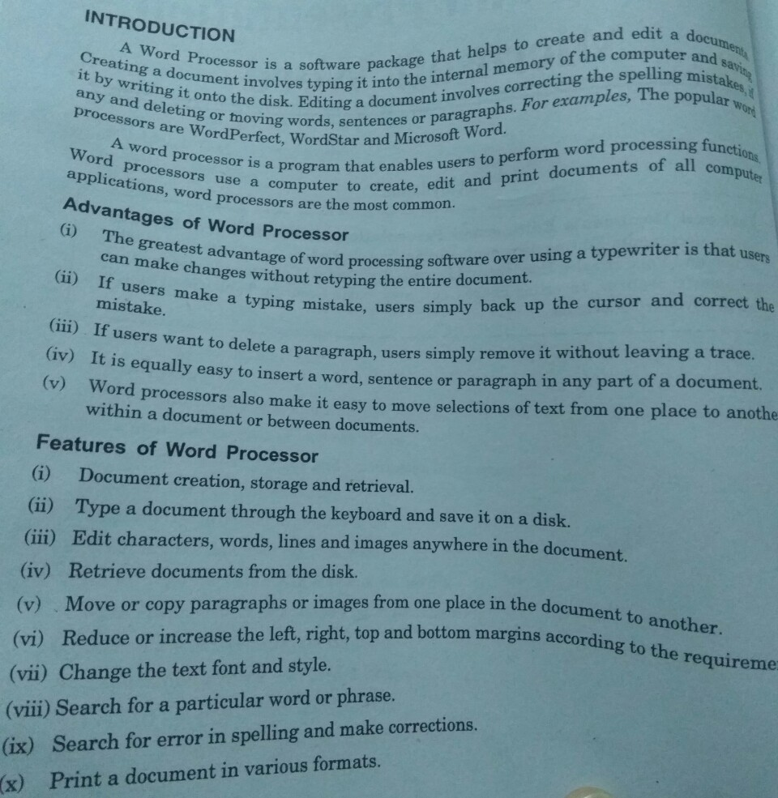

***7 Marks Question –***

***Q1. Define computers and explain its characteristics. What is excel spreadsheet and what are its uses?***

A computer is a device that accepts information (in form of digitalized data) and manipulates it for some result based on a program or sequence of instructions on how the data is to be processed, this device also stores data. The characteristics of computer are -

* ***SPEED***

The computer is a very high speed electronic device.A powerful computer is capable of adding together 2 18 digit numbers in 300 to 400 nanoseconds

* ***ACCURACY***

The computers accuracy is consistently high. Errors in the machinery can occur but, due to increased efficiency in error detecting techniques, these seldom lead to false results.

* ***VERSATILITY***

Computers seem capable to performing almost any task, provided that the task can be reduced to series of logical steps.

* ***AUTOMATION***

A computer is much more than an adding machine, calculator or check-out till, all of which require human operators to press the necessary keys for the operations to be performed. Once a program is in the computer’s memory, the individual instructions are then transferred, one after the other, to control unit for execution.

* ***DILIGENCE***

Being a machine, a computer does not suffer from the human traits of tiredness and lack of concentration. If 3 million calculations must be performed, it will perform the 3 millionth with the same accuracy and speed as the first

* ***RELIABILITY***

The electronic components in modern computer have very low failure rate. Modern computer can perform very complicated calculations without creating any problem and produces consistent results

Excel is the world’s most widely -used spreadsheet program, and is part of the Microsoft office suite. Excel is versatile performing numerical calculations and useful for non - numerical applications. These are the uses of excel

* ***NUMBER CRUNCHING***

Create budgets, analyse survey results, and performs all type of financial analysis

* ***CREATING CHARTS***

Create a wide variety of highly customizable charts

* ***ORGANIZING LISTS***

Use the row and column layout to store lists efficiently

* ***ACCESSING OTHER DATA***

Import data from other sources

* ***CREATING GRAPHICS AND DIAGRAMS***

Use shapes and the new smart Artto create professional - looking diagrams

* ***AUTOMATING COMPLEX TASKS***

Perform a tedious task with a single mouse click with excels’ macro capabilities.

***Q2. Explain the terms internet, intranet and extranet***

* ***INTERNET***

Sometimes called simply as the net, is a worldwide system of computer networks – a network of networks in which users at any one computer can, if they have permission , get information from any other computer . The internet is public, cooperative, and self-sustaining facility accessible to hundreds of millions of people worldwide. Internet uses a set of protocols, that is a set of instructions called TCP/IP.

* **INTRANET**

An intranet is a private network accessible only to an organization's staff. Generally, a wide range of information and services from the organization's internal IT systems are available that would not be available to the public from the Internet. A company-wide intranet can constitute an important focal point of internal communication and collaboration, and provide a single starting point to access internal and external resources. In its simplest form an intranet is established with the technologies for Local area networks (LANs) and Wide area networks (WANs). Intranets began to appear in a range of larger organizations from 1994.

* ***EXTRANET***

An extranet is a Website that allows controlled access to partners, vendors and suppliers or an authorized set of customers – normally to a subset of the information accessible from an organization's Intranet. An extranet is similar to a DMZ is that it provides access to needed services for authorized parties, without granting access to an organization's entire network. An extranet is a private network organization.

Historically the term was occasionally also used in the sense of two organizations sharing their internal networks over a VPN.

***Q3. What is E-commerce? Explain its benefits.***

E-commerce is any business transaction dome via the internet. E -commerce sites objective is to sell products /services directly from the website. E-markets are a part of E - commerce where sellers and buyers meet each other and conduct transactions. There are different types of E commerce

1. ***B2B (BUSINESS TO BUSINESS)***

B2B e- commerce is simply defined as e commerce between companies

1. ***B2C (BUSINESS TO CONSUMER)***

Business to consumer e- commerce, or commerce between companies and consumers

1. ***B2G (BUSINESS TO GOVERNMENT)***

Business to government e-commerce is generally defined as commerce between companies and public sector

1. ***C2C (CONSUMER TO CONSUMER)***

Consumer to consumer e-commerce is simply commerce between private individuals and consumers

1. ***C2B (CONSUMER TO BUSINESS)***

Consumer to business transactions involve reverse auctions, which empower the consumer to drive transactions

* ***Benefits***
* ***Retail and Wholesale***

E-commerce has several uses in retail and wholesale. E-retailing or on-line retailing is the selling of goods from Business-to-Consumer through electronic stores that are designed using the electronic catalogue and shopping cart model. Cybermall is a single Website that offers different products and services at one Internet location. It attracts the customer and the seller into one virtual space through a Web browser.

* ***Marketing***

Data collection about customer behaviour, preferences, needs and buying patterns is possible through Web and E-commerce. This helps marketing activities such as price fixation, negotiation, product feature enhancement and relationship with the customer.

* ***Finance***

Financial companies are using E-commerce to a large extent. Customers can check the balances of their savings and loan accounts, transfer money to their other account and pay their bill through on-line banking or E-banking. Another application of E-commerce is on-line stock trading. Many Websites provide access to news, charts, information about company profile and analyst rating on the stocks.

* ***Manufacturing***

E-commerce is also used in the supply chain operations of a company. Some companies form an electronic exchange by providing together buy and sell goods, trade market information and run back office information such as inventory control. This speeds up the flow of raw material and finished goods among the members of the business community. Companies may not trust their competitors and may fear that they will lose trade secrets if they participate in mass electronic exchanges.

* ***Auctions***

Customer-to-Customer E-commerce is direct selling of goods and services among customers. It also includes electronic auctions that involve bidding. Bidding is a special type of auction that allows prospective buyers to bid for an item. For example, airline companies give the customer an opportunity to quote the price for a seat on a specific route on the specified date and time.

***Q4. What is excel spreadsheet? Explain its uses***

Refer Second Part of Question (1)

***Q5. What is QuarkXPress?***

QuarkXPress is the industry standard page layout program. Although it is professional level application with features that will handle virtually any pre-press circumstances that may occur, it has a user -friendly, intuitive interface and is surprisingly easy to use.

QuarkXPress is designed for printed output. It is used for brochures, ads, newsletters and anything else that appears in print. Although Quark is not specifically made for web pages, there are utilities available such as extensis beyond press which can convert Quark pages into web page.

A page layout program is like a word processor in that a document is built on a page. However, that is where the similarity ends because page layout programs, unlike word processors, allow the precise

arrangement of text AMD images on the page. The first step in making a new document is the creation of the page itself. You determine the page size and dimensions and, like a graphic artist drawing board, Quark open up a work area that looks like a blank page with a pasteboard on either side.

***Q6. What is Ms excel used for?***

Refer Second Part of Question (1)

***Q7. What is typography? State its rules.***

Typography is the art and technique of designing, setting and arranging type. It is used to some degree in all written communication. Graphic design is visual communication that uses design elements to convey print or electronic forms of information. The majority of this information comes from words. Therefore, typography is the most basic form of graphic design and perhaps the most important tool of a graphic designer. Typography can be a very complicated topic but understanding some simple concepts and rules can result in solid typography and help make good graphic design great. Some basic rules of typography are:

* The four most important typographic choices you make in any document are point size, line spacing, line length, and font because those choices determine how the body text looks.
* Point size should be 10–12 points in printed documents, 15-25 pixels on the web.
* Line spac­ing should be 120–145% of the point size.
* The average line length should be 45–90 characters.
* Avoid goofy fonts, mono­spaced fonts, and system fonts, especially Times New Roman and Arial.
* Use curly quotation marks, not straight ones (see straight and curly quotes).
* Put only one space between sentences.
* Don’t use multiple word spaces or other white-space characters in a row.
* Never use underlining, unless it’s a hyperlink.
* Use bold or italic as lit­tle as possible.
* All caps are fine for less than one line of text.
* If you don’t have real small caps, don’t use them at all.
* Use 5–12% ex­tra letter spacing with all caps and small caps.
* Use first-line in­dents that are one to four times the point size of the text, or use 4–10 points of space between paragraphs. But don’t use both.
* If you use justified text, also turn on hyphenation.

***Q8. Write a note on tools in Corel Draw.***

*No Answer. (Refer from notes)*

*Q9. What is internet? Write note on services which we can use with the help of internet.*

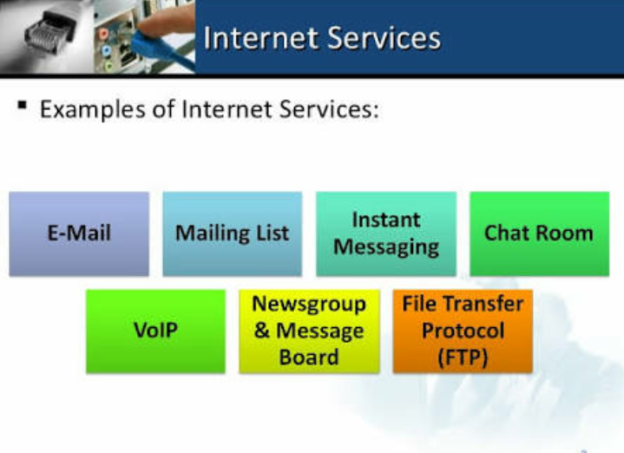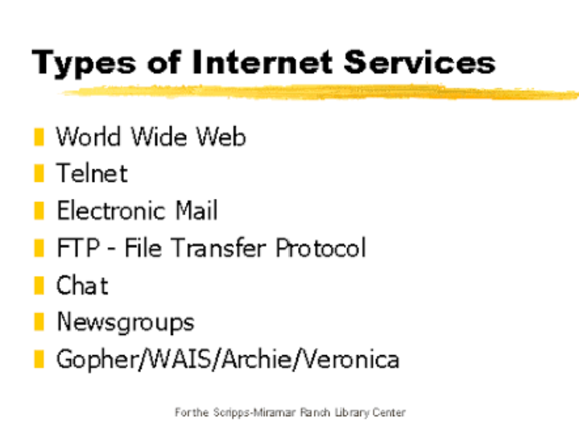A global computer network providing a variety of information and communication facilities, consisting of interconnected networks using standardized communication protocols. Or A means of connecting a computer to any other computer anywhere in the world via dedicated routers and servers.

***Q10. Write a note on MS PowerPoint.***

**Microsoft PowerPoint** is slide show presentation programcurrently developed by Microsoft, for use on both Microsoft and Apple Macintosh operating systems. PowerPoint, initially named "Presenter", was created by Forethought Inc. Microsoft's version of PowerPoint was officially launched on May 22, 1990, as a part of the Microsoft Office Suite. PowerPoint is useful for helping develop the slide-based presentation format and is currently one of the most commonly used slide-based presentation programs available. Microsoft has also released the PowerPoint mobile application for use on Apple and Android mobile operating systems. The following gives you a quick overview of what you

can do in PowerPoint -

* When you create, a presentation using PowerPoint, the presentation is made up of a series of ***slides***. The slides that you create using PowerPoint can also be presented as overhead transparencies or 35mm slides.
* In addition to slides, you can print audience handouts, outlines, and speaker's notes.
* You can format all the slides in a presentation using the powerful ***Slide Master***which will be covered in the tutorial.
* You can keep your entire presentation in a single file- all your slides, speaker's notes, and audience handouts.
* You can import what you have created in other Microsoft products, such as Word and Excel into any of your slides.

***Q11. Write a note on Typography? Explain in brief the options provided in the character panel of Photoshop?***

Typography is an art just like any other. You must feel the form, admire the curves and connect with the flow. You may want to look at the following related posts: Useful Adobe Photoshop Techniques, Tutorials and Tools. In typography, letter-spacing, also called tracking refers to the amount of space between a group of letters to affect density in a line or block of text. Letter-spacing can be confused with kerning. Letter-spacing refers to the overall spacing of a word or block of text affecting its overall density and texture. Typography is the art and technique of arranging type to make written language legible, readable, and appealing when displayed. The arrangement of type involves selecting typefaces, point size, line length, line-spacing, letter-spacing, and adjusting the space within letters pairs. Three fundamental aspects of typography are legibility, readability, and esthetics. Though in a non**-**technical sense **"legible"** and "readable" are often used synonymously, typographically they are separate but related concepts. Legibility and readability tend to support esthetic aspects of a product.

***THE CHARACTER PANEL***

The character panel can be found by going to Window > Character, if it is not already in your right-side panel. It is rich with options for your text,

which we’ll go over now. Be warned, that this section contains complicated typographic terms that you may or may not know.

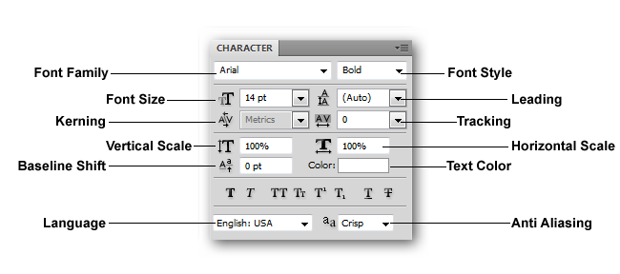

* ***Font Family:*** Where you chose the font your text object is set in, for example, Helvetica, Arial, Times New Roman, etc.
* ***Font Style:*** If you have font families installed, your “font style” may be active, this is where you can choose alternate versions of the same face. For instance, Arial Bold, Arial Narrow, Arial Condensed, Arial Rounded MT, Arial Black, etc.
* ***Font Size*:** Where you can numerically alter the size of your font. Type in numbers here or use the pull-down menu for suggested common point sizes.
* ***Leading:*** Typographic term for the space between lines of paragraph text, set in points.
* ***Kerning:*** Horizontal spacing between pairs of letters. Negative numerical values here will close spaces between characters while positive values will add space between letters.
* ***Tracking:*** Like the concept of Kerning, Tracking adjusts the general kerning over an entire text object or over several selected letters. You can adjust tracking on a text object, and then kern between individual letters, if you wish.
* ***Vertical Scale:*** A controlled way to stretch and squash typography up and down. Input numerical values here in percent of the original character height.
* ***Horizontal Scale:*** A controlled way to stretch and squash typography to the left and right. Input numerical values here in percent of the original character width.
* ***Baseline Shift:*** The baseline is the line the text “rests” on. Move certain selected characters off the baseline to make them appear higher or lower than the rest of the set text.
* ***Text Color:*** An area where text object color can be adjusted.
* ***Language:*** Adjusts the language the text is set in, in case non-English characters are needed.
* ***Anti-Aliasing:*** Options for rendering text in pixels by adjusting the amount of pixel blurring used to describe the edges of type. “None” renders letters in hard-edged pixels, while all others use various forms of anti-aliasing.

***Q12. What is the difference between serif and non-serif fonts?***

Serifs are semi-structural details or small decorative flourishes on the ends of some of the strokes that make up letters and symbols. An example would be the Times New Roman font. Non-serif does not have these details or flourishes. An example would be the Arial font.

It is said that serif fonts are usually easier to read in larger text areas like in books, magazines, in body content on websites. And Non-serif fonts are used regularly because of how clean they tend to look in those main text areas.

***Q13. What is meant by topology? Explain various types of topology.***

The structure, consisting of paths and switches, that provides with the communication interconnections among nodes of a network is called topology. It defines the network in which devices are arranged and

connected to each other.There are five common types of network topologies

* ***Types of Typology:***

1. ***Bus/Linear topology:*** A single main cable connects each node of computer which allows accessing of computers end-to-end. Each node is connected to two others except those in end. This topology is often found in client / server systems, where one of the machines on the network is designated as file server. It is the simplest and widely used topology of computers all connected by a single length of cabling with a terminator at each end.
2. ***Ring/Circular topology:*** Data travels around the ring in one direction, with each of the device acting on the ring as a repeatator. Nodes are connected using cable segment in a circle. Each node passes information along to the next, until it reaches its intended destination. It uses a Token Passing Protocol showing all PC’s passing on the information provided and where failure of single nodes stops the entire action. It is usually found in peer-to-peer connection (PC connected in pairs)
3. ***Star topology:*** All the cables run from the computer to a central location, where they are connected by a hub. Hub is a device used to extend the network so that additional work stations can be also added. Each is connected to single centrally located server, using its own dedicated segment of cable. The switch provides a path between any two devices wishing to communicate according on their basis of need.
4. ***Tree topology:*** This is a network of topology containing zero or more nodes / computers linked together in a hierarchical function. The topmost node is called the root. Nodes sharing the same parent is called siblings. Every node in the tree has exactly one parent node (except the roots, which has no parents). There is only path from one node to another node in tree topology.
5. ***Mesh/Graph topology:*** In this topology, two or more nodes are connected to each other in arbitrary fashion. Any two nodes in Mesh or Graph topology may or may not be connected by a link. Not every node needs to be connected in a graph, but if the path can be traced between any two nodes, the graph is a connected one. It has no restriction of connection among all the nodes in a network.

***Q14. What is the effect of internet on journalism and journalist?***

The explosive rate at which the internet has penetrated every aspect of journalism has made it an endless topic of speculation & debate among journalist, scholars & the public. Not only did the internet diffuse through journalism more rapidly and more completely than other once new technologies, computer-mediated communication and the internet has had an impact on every aspect of journalism. The internet has emerged as a new medium of publication, a new tool for reporting, and a new focus for journalism education. Moreover, the internet has raised new questions about the social responsibilities of journalists to inform the public as well as the ethical practice of journalist. Finally, the internet is an international medium. Consequently, its impact has been felt around the globe. People report their own news about themselves from their own communities, using available simple media technologies such as hand cameras, cellular/mobile phones and internet blogging. With the use of mobiles phones for example, photos and voice recordings that had been hitherto unavailable, are now used as actualities in TV and radio broadcasts, often supplied by mere citizens who may not have had any substantial and professional media training. With the new media technologies and the involvement of citizens to report their own news in their own way and about events in their communities, one would say that the news is everywhere and that there is nowhere to hide. It has great transparency and account ability in the governance process as there are alternative ways of publicizing news and information. People now can respond in time to what they see, hear and read in the main stream media as mobile phones and internet services have placed the power of reporting in the hands of the public. It has created a window of opportunity for the exercise of the freedom of expression as well as the right to participate. It has greatly enhanced the development of the media in that news producer and recipients are now interacting. Its reach is beyond computers. It serves as a platform for other technologies to interoperate with mobile device, iPad, & home entertainment devices etc.

***8 Marks Questions*** –

**Q1. Explain basic terms of designing industry**

Graphic design, like any profession, is littered with jargon and terms you may not be familiar with. Here are just some of the key terms you should know, and a brief explanation of them.

* ***Raster images & Vector images***

Raster images (sometimes referred to as bitmap images) are made up of thousands of pixels which determine the color and form of the image.

Photos are raster images. Photoshop is the most common raster editor, enabling you to manipulate the color and other properties of the pixels. But, because raster images are made up of a finite number of pixels, resizing can be tricky. If you make raster image larger dimensions in Photoshop, the software must make up data to add the size. This results in loss of quality.

Vector-based images (such as those created in Adobe Illustrator) are made up of points, each of which has a defined X and Y coordinate. These points join paths to form shapes, and inside these shapes you can add color fills. Because everything is generated based around this, vectors can be resized to any size without any loss of quality.

* ***CMYK & RGB***

CMYK is the standard color mode for sending documents - be it magazines, newspapers, flyers, brochures, annual reports and so on to the printers. It stands for Cyan, Magenta, Yellow and Key (or black - key because in four-color printing, cyan, magenta, and yellow printing plates are carefully keyed, or aligned, with the key of the black key plate). When you send a job to the press, cyan, magenta, yellow and black plates are made (on a traditional press, anyhow) and then aligned to print on paper. You can add Pantone, or fifth colors, which are created as separate plates. Because CMYK has a more limited color gamut than RGB (which is essentially what the eye sees and how screens output) you can experience a loss of color when converting from RGB to CMYK in these applications.

* ***DPI and PPI***

Resolution is another key term that is often confused. There are two main acronyms used when dealing with resolution: DPI and PPI.

The former is only of concern when you're creating work for printed output. It stands for 'Dots per Inch' and refers to the number of dots per inch on a printed page. Generally, the more dots per inch, the better quality the image - and 300DPI is the standard for printing images.

PPI refers to 'Pixels per Inch' and, as you'd expect, is the number of pixels per inch in your image. If you resize an image in Photoshop - making it larger - you will increase the number of pixels per inch (with Photoshop making up the data) and you will lose quality.

Resolution only applies to raster graphics - because vectors do not work in pixels.

***Q2. Explain mail merge in MS Word***

The automatic addition of names and addresses from a database to letters and envelopes to facilitate sending mail, especially advertising, to many addresses.

* ***Steps***
* Type or add any text and graphics that you want to include in your letter.
* Add the field codes where you want the variable information to appear. In the Mail Merge task pane, you have four options:
* Address block: Use this option to insert a formatted address.
* Greeting line: Use this option to insert a formatted salutation.
* Electronic postage: Use this option to insert electronic postage.
* In the Insert Merge Field dialog box, click the merge field that you want to use, and then click Insert.
* When you finish editing the main document, click Save or Save As on the File menu.
* Note in Word 2007, click the Microsoft Office Button, and then click Save or Save As.
* Name the file, and then click Save. To proceed to the next step, click Next:
* Preview your letters.
* This step allows you to preview your merged data, one letter at a time. You can also make changes to your recipient list or personalize individual letters.
* To proceed to the next step, click Next:
* Complete the merge
* This step merges the variable information with the form letter. You can output the merge result by using either of the following options:
* Print: Select this option to send the merged document directly to the printer. You will not be able to view the document on your screen.
* When you click Print, the Merge to Printer dialog box appears. In the Merge to Printer dialog box, you can choose which records to merge. When you click OK, the Print dialog box appears. Click Print to print the merge document.
* Edit individual letters: Select this option to display the merged document on your screen.
* When you click Edit individual letters, the Merge to New Document dialog box appears. In the Merge to New Document
* dialog box, you can choose which records to merge. When you click OK, the documents are merged to a new Word document.
* To print the file, on the File menu, click Print.

***Q3. Explain various types of scanners***

The most popular type of desktop scanner is the ubiquitous flatbed scanner, so called because of its flat, glass platen (or bed) which serves as both the scanning area and surface for laying objects down to be scanned. Most flatbeds are used for scanning reflective art.

* ***Flatbed Scanners***

Entry-level flatbed scanners generally share the following specifications: 8-1/2" x 11" scanning area, 300 to 400 spi scanning ability (often interpolated to 800, 1200, or 1600 "spi"), 8-bits per color channel, and low cost. They often come bundled with powerful "value-added" software such as Adobe Photoshop. These machines frequently offer excellent price/performance ratio. Because there is fierce competition for this market, at the time of this writing, the magic price for entry-level scanners seems to be hovering around the $1000-$1200 mark.

Mid-level flatbed scanners differ from their entry-level cousins in three important ways: First they cost much more! Second, because they're targeted toward a more professional market, they rarely come bundled with "value-added" software such as Photoshop. Third, and most importantly, they have significantly better specifications. For example, a typical mid-level flatbed scans at 600x1200 spi and 10-bits per color, resulting in scans of significantly higher quality. Some mid-level scanners may also offer a larger scanning area.

* ***Transparency Scanners***

Multi-format transparency scanners allow you to scan everything from 35mm slides all the way up to 4x5-in. transparencies. These scanners are targeted to professionals only and thus cost quite a bit. In fact, these high-end transparency scanners are muscling-in on the once exclusive domain of drum scanners by offering more features, better software, and faster scanning time.

Slide scanners cost a lot more than the relatively inexpensive flatbed transparency option. For those who may need only an occasional transparency scanned, a flatbed with transparency adapter is the way to go. But if you scan a lot of transparencies, then the only equipment that offers the best quality scans are dedicated transparency scanners.

* ***Handheld Scanners***

Hand scanners are useful for their portability and low price (often one-third to a quarter of the cost of a flatbed scanner). Hand scanners generally plug into a computer's printing port, as opposed to a SCSI port, allowing them to be easily shared from workstation to workstation. Many people find them ideal for use with a notebook or laptop. Unfortunately, hand scanners are less accurate than flatbeds because they have weaker light sources and often produce uneven scans - courtesy of the unsteadiness of your hand or the surface you're standing on. Many hand scanners now offer an alignment template to help guide you when scanning. At least one manufacturer ships a motorized "self-propelled" unit to help stabilize its scanner.

* ***Drum Scanners***

Professional color trade shops wouldn't think of using anything less than a drum scanner for producing color separations for high-end printing. Instead of using CCD technology, drum scanners use PMT (Photo Multiplier Tube) technology for greater dynamic range and color accuracy. They also cost an arm and a leg, Nevertheless, drum scanners offer features not available to desktop scanners such as direct conversion to CMYK, auto sharpening, batch scanning, greater dynamic range, and huge image scanning areas. Ironically, most drum scanners don’t support preview mode - drum scanner operators are more interested in numbers than what they see with their eyes. Yet what truly sets drum scanners apart is their increased productivity. Since the process of scanning to CMYK is automated, drum scanners can produce more scans per hour than a desktop unit.

***Q4. Digital Computers***

Digital computer, any of a class of devices capable of solving problems by processing information in discrete form. It operates on data, including magnitudes, letters, and symbols, that are expressed in binary code - i.e., using only the two digits 0 and 1. By counting, comparing, and manipulating these digits or their combinations according to a set of instructions held in its memory, a digital computer can perform such tasks as to control industrial processes and regulate the operations of machines; analyze and organize vast amounts of business data; and simulate the behavior of dynamic systems (e.g., global weather patterns and chemical reactions) in scientific research. A brief treatment of digital computers follows. A typical digital computer system has four basic functional elements:

(1) input-output equipment,

(2) main memory,

(3) control unit, and

(4) arithmetic-logic unit.

Any of several devices is used to enter data and program instructions into a computer and to gain access to the results of the processing operation. Common input devices include keyboards and optical scanners; output devices include printers and monitors. The information received by a computer from its input unit is stored in the main memory or, if not for immediate use, in an auxiliary storage device. The control unit selects and calls up instructions from the memory in appropriate sequence and relays the proper commands to the appropriate unit. It also synchronizes the varied operating speeds of the input and output devices to that of the arithmetic-logic unit (ALU) to ensure the proper movement of data through the entire computer system. The ALU performs the arithmetic and logic algorithms selected to process the incoming data at extremely high speeds - in many cases in nanoseconds (billionths of a second). The main memory, control unit, and ALU together make up the central processing unit (CPU) of most digital computer systems, while the input-output devices and auxiliary storage units constitute peripheral equipment. The English inventor Charles Babbage, however, is generally credited with having conceived the first automatic digital computer. During the 1830s Babbage devised his so-called Analytical Engine, a mechanical device designed to combine basic arithmetic operations with decisions based on its own computations.

**Q5. What is PowerClip effect in Corel draw?**

PowerClip gives you the ability to place an object or multiple objects inside a container. This container can be made up of a single object, several objects, or text.

* ***Creating a Masthead***

***To begin, start by typing your text:***

* In the Toolbox, select Artistic Text tool;
* Click on your desktop screen;
* Type the following text: HAWAII
* Select the text (you may press Ctrl-Shift-back arrow);
* Resize the text by either dragging the corner of the text box or by typing a value in the Interactive Property Bar. In our example, we set the value to 90 px.
* Change the font typeface to Cooper Black;
* Deselect the text by selecting the Pick tool and then left-click a blank spot on the desktop screen;
* ***Importing an image:***

***Bring in the image that you want to PowerClip inside this text or container:***

* You can either go to File menu > Import or simply click on Import icon in the Interactive toolbar;
* Click and drag the size that you want this image to be.
* Press Shift + F4 on your keyboard to see entire page.
* Move the image off to the side so you can see the text.

***Applying the PowerClip to the image into the text***

* While the image is selected, go to the Effect menu > PowerClip > Place inside Frame (early versions of CorelDraw will have “place inside container”);
* Use the Bold arrow to click on the text; this will place the image inside the text.

***Resizing the image to fit inside the text or container***

* To edit the image, you can either: Go to Effects menu > PowerClip> Edit PowerClip; Or, hold the Ctrl key on your keyboard and click on top of container to go into Edit mode (you may have to click twice if the image was not selected to begin with);
* In the edit window, click the image then resize it to ﬁt in the text.
* Hold the Ctrl key down and click outside the frame to ﬁnish editing.

**Bringing in another image:**

* Click on Import and choose image;
* Select Import, click and drag to place on the desktop screen.

***Adding drop shadow to your masthead***

* From the Interactive tools menu, select Drop Shadow. Click and drag to create a drop shadow for this image. Use the slider to adjust the amount of shadow.
* Additionally, you can left click on the image to bring up another slider which allows you to adjust the intensity of the shadow.

You are done. Your masthead is ready to adorn your travel brochure.

***Q6. Steps to put watermark in MS word***

Watermarks in this Office Version can be viewed only in Print Layout and Full Screen Reading views and on the printed page.

* **On the Page Layout tab, in the Page Background group, click Watermark.**
* **Do one of the following:**

Click a pre-designed watermark, such as Confidential or Urgent, in the gallery of watermarks. Click Custom Watermark, click Text watermark and then select or type the text that you want. You can also format the text. But how do you write in 2 lines? The watermark is stored in the header/footer layer. So, opening the header for editing would be a way to gain access. Also... if the watermark is submerged under text, you might need to click the Select Object tool to be able to select the picture. In Word 2007, this is in the Home tab, right end of the ribbon under Find and Replace. Click Select - Select Objects. You should then be able to select the drawing for editing.

* **To view a watermark as it will appear on the printed page, use Print Layout view.**

***Q7. Computers Hardware and Software?***

* ***Hardware***

Hardware refers to the physical elements of a computer. This is also sometime called the machinery or the equipment of the computer. Examples of hardware in a computer are the keyboard, the monitor, the mouse and the processing unit. However, most of a computer's hardware cannot be seen; in other words, it is not an external element of the

computer, but rather an internal one, surrounded by the computer's casing (tower). A computer's hardware is comprised of many different parts, but perhaps the most important of these is the motherboard. The motherboard is made up of even more parts that power and control the computer. In contrast to software, hardware is a physical entity. Hardware and software are interconnected, without software, the hardware of a computer would have no function. However, without the creation of hardware to perform tasks directed by software via the central processing unit, software would be useless. Hardware is limited to specifically designed tasks that are, taken independently, very simple. Software implements algorithms (problem solutions) that allow the computer to complete much more complex tasks.

* ***Software***

Software, commonly known as programs, consists of all the electronic instructions that tell the hardware how to perform a task. These instructions come from a software developer in the form that will be accepted by the platform (operating system + CPU) that they are based on. For example, a program that is designed for the Windows operating system will only work for that specific operating system. Compatibility of software will vary as the design of the software and the operating system differ. Software that is designed for Windows XP may experience a compatibility issue when running under Windows 2000 or NT.

Software can perform many tasks, as opposed to hardware which only perform mechanical tasks that they are designed for. Software is the electronic instructions that tells the computer to perform a task. Practical computer systems divide software systems into two major classes:

* ***System software:*** Helps run computer hardware and computer system itself. System software includes operating systems, device drivers, diagnostic tools and more. System software is almost always pre-installed on your computer.
* ***Application software:*** Allows users to accomplish one or more tasks. Includes word processing, web browsing and almost any other task for which you might install software. (Some application software is pre-installed on most computer systems.)

Software is generally created (written) in a high-level programming language, one that is readable by people. These high-level instructions are converted into "machine language" instructions, represented in binary code, before the hardware can "run the code". When you install software, it is generally already in this machine language, binary, form.

***Q8. Explain text formatting buttons from home tab in MS word?***

* ***Home Tab***

Most of those frequently used commands are in the Home Tab. When you open Microsoft Word 2007 you will notice that instead of toolbars and drop down menus, you will see what is called a Ribbon.  The Ribbon is located close to the top of the Word window.  The Ribbon is organized into a set of task oriented tabs, and each tab on the Ribbon contains groups of commands.  The Home Tab contains the most frequently used commands in Word.  To get to another tab on the Ribbon click that tab. If you do not see a command(s) that you’re looking for click the arrow beside each group name that looks like this to open a dialog box with more commands. For example, to get the Emboss text effect, you would go to the Font Group and under the second line of commands, there is the word “Font”, click the arrow beside it to open a Font Dialog Box, select “Emboss” and click OK. Below are some more commands that are featured on the Home Tab.

***Increase or Decrease the Font Size using Grow Font and Shrink Font***

* Use the mouse pointer to highlight the text for which you want to change the font.
* In the Font group, click the Grow Font   or Shrink Font button.  The Font size will change accordingly.

***Change Font***

* Use the mouse pointer to highlight the text you want to change.
* In the Font group, click on the box containing the name of the font.  A gallery opens containing names and examples of available fonts.
* As you point to each font, Word allows you to preview its effects on selected text.
* Click on a font name to apply the changes permanently to the selected text.

***Reset Font***

* Use the mouse pointer to select the text from which you want to clear the formatting
* In the Font group, click Clear Formatting Button.  The formatting will be removed from the text, leaving only the plain text.

***Formatting Marks – On/Off***

* In the Paragraph group, click the Show/Hide Button.  You now see formatting marks in the document.
* Click the button again to hide the marks.

***Using Bullets & Numbering***

* In the Paragraph group, click the Bullets or Numbering button.  The next line will be indented and preceded by a bullet or number.
* Enter your text and press ENTER.  Word automatically indents the next line and begins it with a bullet or number.
* Click the Bullets or Numbering button to turn off bullets or numbering.
* To change your Bulleting or Numbering Style click the small arrow next to the Bulleted List Icon or Numbering List Icon. Clicking that arrow will give you a drop‐down list of all available styles.

**Quickly Format Text**

* Select the text to which you want to apply a Quick Style, or if you want to change the style for an entire paragraph, click anywhere in the paragraph.
* In the Styles group, click the “More” button to open the Styles Gallery.
* Click the desired Quick Style to apply it to the selected text or paragraph.

***Align Text***

* Use the mouse pointer to highlight the text you want to align.
* In the Paragraph group, click the desired option (Align text Left, Center, Right or Justify).

**Note – *the following question which are not there here can be found in other sections of the question bank (5 marks or 7 marks or 15 marks) Or refer from notes/textbook, as the answers are similar.***

***Q17. What are Printers and their types?***

Printers can be categorized into **Impact Printers** & **Non-impact Printers**

* ***Impact Printers***

#### These are those types of printers which have direct mechanical contact between the head of the printers and paper. The impact printers are

1. **Dot Matrix Printers:**

These Printers print characters as a combination of dots arranged in a 5 x 7 matrix. The speed of these printers varies from about 30 to 600 characters per second. The printing head of these printer contains a

vertical array of pins, which fires the selected pins against carbon ribbon or linked surface e while the head moves across the paper to form a pattern of dots representing characters. These printers can print characters in draft quality, standard quality as well near letter quality.

1. **Daisy Wheel Printers:**

This printer is a solid font type character printer. The printing arms of the printer head look like petals of the flower. This printer is very slow, it prints about 60-90 characters per second. The hub rotates continuously, rotating at high speed and hammer strikes the appropriate character in its position. This printer also acts as a bi-directional printer.

1. ***Line Printers:***

These printers print the total line at a time, giving the name line printers. They can be print 1000- 5000 lines per minute

* **Non -Impact Printers:**

These printers print without any direct mechanical contact between the head of the printer and paper. These printers can be categorized into

* **Thermal Printers:**

These Printers uses heat sensitive paper in dot matrix method, on which hot needles are pressed to form characters. These printers print slow and make a little noise. The disadvantage is that it is not possible to print multiple copies simultaneously.

* **Inkjet Printers:**

These printers use a mechanism where it sprays the ink from tiny nozzles through an electric field that arranges charged particles ink into characters. The paper absorbs the ink and it dries instantaneously. It is capable to print about 500cps, expensive but faster and we can also have color printing, by using ink various colors.

* **Laser Printer:**

This type of printers uses laser beams which charge the drum negatively, to which black toner powder which is positively charged is stuck. When the paper rolls by the drum, the toner powder is transferred to the paper. These printers are very fast, quality is very good and speed about is 15,000 to 20,000 lines per minute.

* **Electrographic Printer:**

This printer writes on special paper using electricity. The paper is held between two electrodes. These printers can either use wet process or dry process. The speed of these printers is high and is about 20,000 cps. These printers are very reliable as there are very less moving parts.

* ***Electro Static Printer:***

This printer uses a mechanism, where static electricity is used to create impressions on special paper. The charges attract toner power to the charged spots, giving the print. These printers are very fast and are capable for plotting graphs etc. The speed is very high i.e. up to 20,000 lines per minute.

***Q25. Explain in Detail Vector and bitmap images?***

Digital images can usually be divided into two distinct categories. They are either bitmap files or vector graphics. If you work in prepress, you need a good understanding on the advantages and disadvantages of both types of data. These pages try to explain the differences. As a rule, digital pictures and scanned images are bitmap files. These are sometime also called raster images. Drawings made in applications like Adobe Illustrator or Corel Draw are saved as vector graphics.

* ***Bitmap images***

Bitmap images are exactly what their name says they are: a collection of bits that form an image. The image consists of a matrix of individual dots (or pixels) that all have their own colour (described using bits, the smallest possible units of information for a computer).

***Characteristics of bitmap data***

* Bitmap data can take up a lot of room. A CMYK A4-size picture that is optimized for medium quality printing (150 lpi) takes up 40 MB. Compression can reduce the size of the file.
* The image with the enlargement showed one of the main disadvantages of bitmap images: once they are enlarged too much, they look unnatural and blocky. Reducing their sizes also has an impact on image quality as images lose a bit of sharpness.
* Bitmaps are simple to output, if your RIP or printer has sufficient memory.
* ***Vector graphics***

Vector graphics are images that are completely described using mathematical definitions. The image below shows the principle. To the left, you see the image itself and to the right you see the actual lines that make up the drawing.

***Characteristics of vector drawings***

* Vector drawings are usually small files because they only contain data about the Bézier curves that form the drawing. The EPS file format that is often used to store vector drawings includes a bitmap preview image along the Bézier data. The file size of this preview image is usually larger than the actual Bézier data themselves.
* Vector drawings can usually be scaled without any loss in quality. This makes them ideal for company logos, maps or other objects that must be resized frequently. Please note that not all vector drawings can be scaled as much as you like:
* Drawings containing trapping information can only be scaled up to 20 percent larger or smaller.
* Thin lines may disappear if a vector drawing is reduced too much.
* Small errors in a drawing may become visible as soon as it is enlarged too much.
* It is easy to create a vector based drawing that is very difficult to output. Especially the use of tiles (small objects that are repeated dozens or hundreds of times) and Corel Draw lens effects can lead to very complex files.

***Q26. What do you mean by resolution- Screen resolution and Print resolution.***

In computers, resolution is the number of pixels (individual points of colour) contained on a display monitor, expressed in terms of the number of pixels on the horizontal axis and the number on the vertical axis. The sharpness of the image on a display depends on the resolution and the size of the monitor. The same pixel resolution will be sharper on a smaller monitor and gradually lose sharpness on larger monitors because the same number of pixels are being spread out over a larger number of inches. A given computer display system will have a maximum resolution that depends on its physical ability to focus light (in which case the physical dot size - the dot pitch - matches the pixel size) and usually several lesser resolutions.

***Screen resolution*** - It refers to the clarity of the text and images displayed on your screen. At higher resolutions, such as 1600 x 1200 pixels, items appear sharper. They also appear smaller so more items can fit on the screen. ... The larger the monitor, usually the higher the resolution it supports.

***Print resolution*** - In printing, DPI (dots per inch) refers to the output resolution of a printer or image setter, and PPI (pixels per inch) refers to the input resolution of a photograph or image. DPI refers to the physical dot density of an image when it is reproduced as a real physical entity, for example printed onto paper.

***Q27. Discuss is CMYK & RGB?***

﻿

Scanners, digital cameras and computer monitors use red, green and blue (RGB) light to display colour. ﻿Commercial printing presses print with cyan, magenta, yellow and black (CMYK) ink, called process printing, instead of RGB light, and therefore produce a different range of colour. See 4 colour process printing explained for more info. To print on a four-color press, all RGB files must be converted into CMYK colour.

RGB lights combine to make white

CMYK inks combine to create black Certain RGB colours that you can see on your monitor or camera (in particular, bright vibrant colours) simply cannot be replicated with standard CMYK inks. These unachievable RGB colours are said to be "out of the CMYK colour gamut." When selecting colours for your print project, we recommend using CMYK colour builds to avoid potential RGB conversion issues. You are more likely to notice colour shifts when you use a solid, bright colour as a background or fill.

﻿A highly useful tool for selecting reproducible CMYK colours is the Pantone Process Colour Guide. This swatch guide displays over 3,000 colours with corresponding colour builds, and is available on both coated and uncoated stock. Strongly recommended if you will be doing repeat printing projects, or have colour concerns.

***Q28. Discuss Margin and bleed?***

Columns are the width and area that text will be designated, margins are the distance to the edge of the page that the columns will live in and, bleeds you can extend out and beyond the margins right off the page You notice in some dtp that images go right to the edge, thus bleed is used to maximum, you would not however put text in your bleed as the accuracy of where the cut takes place lies within the crop area inside the page..

* ***Bleed***: Any text or graphic element touching the edge of a page is called a bleed. Often done intentionally for non-text objects, text running out to the edge of a page appears untidy and shows that the page layout did not allow for enough trim space.

Margin guides or margin guidelines form the non-printing rectangle that makes up the printable area of a page.

***Q29. What is a Sprite in Scratch Animation Programming? how will you animate a character to make him dance in Scratch? Mention steps.***

Sprites, either user-created, uploaded, or found in the sprites library, are the objects that perform actions in a project. While the Stage can also be programmed in a project, most projects have at least one sprite as well because only sprites can move. The bar above the sprite list has four buttons for creating sprites. They are:

The Giga button allows you to choose a sprite from the library. The paintbrush button creates a blank sprite with an empty costume. The folder button allows you to upload a sprite from your computer. The camera button allows you to take a picture and uses that image as the costume. When a sprite is created, it will place that sprite at a random location on the Stage, usually around the centre, and open the sprite in the tab you're currently viewing.

***Step by Step instructions to make a character dance on Scratch Project***

* Open Scratch on your computer. The stage is ready with the Cat as sprite1.
* ***Loop***: Continue a step (or sequence of steps) forever. Forever loop makes the cat move back and forth on drum beats forever (until you stop the script by “Stop” button. It means those blocks are running in loop forever.
* ***Control Event***: The cat starts moving whey “When Green Flag Clicked”. That’s the command or control or event to start the Scratch Script.

***Q30. What is symbols? What is the use of symbols?***

A symbol is a mark, sign, or word that indicates, signifies, or is understood as representing an idea, object, or relationship. Symbols allow people to go beyond what is known or seen by creating linkages between otherwise very different concepts and experiences. All communication (and data processing) is achieved through the use of symbols. Symbols take the form of words, sounds, gestures, ideas or visual images and are used to convey other ideas and beliefs. For

example, a red octagon may be a symbol for "STOP". On a map, a blue line might represent a river. Numerals are symbols for numbers. Alphabetic letters may be symbols for sounds. Personal names are symbols representing individuals. A red rose may symbolize love and compassion. The variable 'x', in a mathematical equation, may symbolize the position of a particle in space.

***Q31. Give a brief about pathfinder and brief mode options.***

Illustrator Pathfinder palette is a simple and Powerful set of tools for manipulating shapes and creating other shapes from multiple shapes. I use illustrator on my Job all day; I find myself using the Pathfinder at least once for each job I do. Illustrator Pathfinder Basic Tutorial:

The Pathfinder palette is very simple to use. Each of the buttons interacts with 2 or more shapes. Each button has a very specific action. These buttons can be confusing because some of them do the same thing. I show examples later in this tutorial which aim at showing the differences between each button. To begin, I will show you how to use the first button “Add to Shape Area” to make an object out of several different objects.

* Make a new Illustrator document and draw a circle, a long rectangle and then 2 smaller rectangles like the object you see below (The idea here is to make a simple “key shape” from multiple objects, using the pathfinder)
* Click the “Add to Shape Area” button.
* Click the “Expand” button. You will notice that all the shapes are merged, but when you select the object you see all of the shapes that were there before. Clicking the “Expand” button permanently joins all the shapes as one. You don’t have to press “Expand” after using the Pathfinder tools, only use it if you want to permanently join the shape so you can do other pathfinder operations with it (Which we will be doing in the next steps).
* Draw a smaller circle inside the large circle (or handle) of the key shape.
* Select both shapes and press the second pathfinder button “Subtract from shape area”.

Now we have a key shape made from various simple shapes. It’s a pretty simple shape — but this is a start. I will publish some advanced pathfinder tutorials in the future.

***Q32. Explain the process in a tabular format.***

"Tabular format" is simply information presented in the form of a table with rows and columns. Most office productivity software programs, such as word processors and spreadsheets, include tools for entering text and data in tabular format. You can then enhance the appearance of the table by adjusting fonts, borders, backgrounds and other visual features. A data table is a neat and convenient way to present a large body of information that includes repeating data elements. For example, each entry in a list of company clients contains the client's name, title, address, phone number and other identifying information. This information can be listed in tabular format -- that is, in rows and columns - by using separate columns for each data element. Columns are usually identified with headers such as "Client Name," "Street Address" and "Email Address," and each row contains all the information for a single client.

***Q34. Explain the various kinds of functions offered by MS Excel through relevant examples / diagrams.***

### ***IF Functions***

This Excel function is used for testing whether certain conditions are true or false and helps in arriving at decisions in a spreadsheet. You can create nested IF Functions to make the functions more flexible, perform calculations, enter data or text, or to leave a cell blank when certain IF conditions are met. The following examples demonstrate the simplest IFERROR formula:

### ***IFERROR formula example DATE Functions***

Another useful Excel function is the DATE Function which you can use to add the current time or day of the week to specific cells in your spreadsheet. There are two types of the DATE functions:

* NOW for entering the current time and date.
* NETWORKDAYS function for finding the number of days that a project entails

***Current date and time***

* Today-returns the current date
* Now - returns the current date and time.

### ***Extracting dates and date components***

### Day - returns the day of the month.

### MONTH - returns the month of a specified date.

### YEAR - returns the year of a specified date.

### EOMONTH - returns the last day of the month.

### WEEKDAY - returns the day of the week.

### WEEKNUM - returns the week number of a date.

### ***Calculating date difference***

### DATEDIF - returns the difference between two dates.

### EDATE - returns a date that is the specified number of months before or after the start date.

### YEARFRAC - calculates the fraction of the year between 2 dates.

### ***Calculate workdays***

### WORKDAY - calculates a date that is a specified number of working days before or after the start date.

### WORKDAY.INTL - calculates a date that is a specified number of weekdays before or after the start date, with custom weekend parameters.

### NETWORKDAYS - returns the number of working days between two dates.

### NETWORKDAYS.INTL - returns the number of workdays between two dates with custom weekends.

### ***Logical Functions***

Microsoft Excel provides a handful of logical functions that evaluate a specified condition(s) and return the corresponding value.

### AND, OR, XOR functions

* AND (logical1, [logical2], …) - returns TRUE if all of the arguments evaluate to TRUE, FALSE otherwise.
* OR (logical1, [logical2], …) - returns TRUE if at least one of the arguments is TRUE.
* XOR (logical1, [logical2],) - returns a logical Exclusive Or of all arguments. This function was introduced in Excel 2013 and is not available in earlier versions.

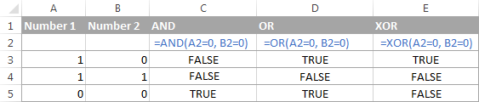

## ***Math Function***

Excel has a ton of basic and advanced functions to perform mathematical operations, calculate exponentials, logarithms, factorials and the like. It would take several pages just to publish the functions list. So, let us discuss only a few basic math functions that may prove useful for solving your daily tasks.

***Finding the sum of cells,*** four essential Excel functions to add up the values of cells in a specified range follow below.

#### **SUM function, SUM (number1, [number2],…)** returns the sum of its arguments. The arguments can be numbers, cells reference or formula-driven numeric values.

For example, the simplest math formula =SUM (A1:A3, 1) adds up the values in cells A1, A2 and A3, and then adds 1 to the result. the following screenshot gives an idea of how the SUMIF and SUMIFS functions can be used on real-life data:

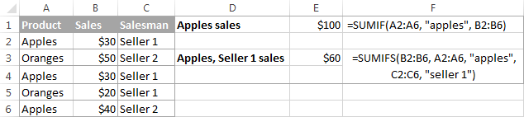

***Q35. Explain the file format supported by Photoshop.***

Photoshop format (PSD) is the default file format and the only format, besides the Large Document Format (PSB), that supports all Photoshop features. Because of the tight integration between Adobe products, other Adobe applications, such as Adobe Illustrator, Adobe InDesign, Adobe

Premiere, Adobe After Effects, and Adobe Go Live, can directly import PSD files and preserve many Photoshop features. For more information, see Help for the specific Adobe applications. When saving a PSD, you can set a preference to maximize file compatibility. This saves a composite version of a layered image in the file so it can be read by other applications, including previous versions of Photoshop. It also maintains the appearance of the document, just in case future versions of Photoshop change the behavior of some features. Including the composite also makes the image much faster to load and use in applications other than Photoshop, and may sometimes be required to make the image readable in other applications. You can save 16-bits-per-channel and high dynamic range (HDR) 32-bits-per-channel images as PSD files.

***Q36. Discuss Raster & Vector Graphics.***

Raster images are made of pixels. A pixel is a single point or the smallest single element in a display device. If you zoom in to a raster image you may start to see a lot of little tiny squares. Vector images are mathematical calculations from one point to another that form lines and shapes. If you zoom into a vector graphic it will always look the same. A raster image has a specific number of pixels. When you enlarge the image file without changing the number of pixels, the image will look blurry. When you enlarge the file by adding more pixels, the pixels are added randomly throughout the image, rarely producing good results. When you enlarge a vector graphic, the math formulas stay the same, rendering the same visual graphic no matter the size. Vector graphics can be scaled to any size without losing quality.

***Q37. Write a detailed note on input and output devices of computer.***

The devices which are used to input the data and the programs in the computer are known as "**Input Devices**". or Input device can read data and convert them to a form that a computer can use. **Output Device**

can produce the final product of machine processing into a form usable by humans. It provides man to machine communication. Some of the I/O devices are explained below:

* ***Keyboard***: Keyboard is used in the input phase of a computer-based information system. Keyboard is most common input device is used today. The data and instructions are input by typing on the

keyboard. The message typed on the keyboard reaches the memory unit of a computer. It’s connected to a computer via a cable. Apart from alphabet and numeral keys, it has other function keys for performing different functions.

* ***Mouse***: It’s a pointing device. The mouse is rolled over the mouse pad, which in turn controls the movement of the cursor in the screen. We can click, double click or drag the mouse. Most of the mouse’s have a ball beneath them, which rotates when the mouse in moved. The ball has 2 wheels of the sides, which in turn mousse with the movement of the ball. The sensor notifies the speed of its movements to the computer, which in turn moves the cursor/pointer on the screen.
* ***Scanner***: Scanners are used to enter information directly in to the computer’s memory. This device works like a Xerox machine. The scanner converts any type of printed or written information including photographs into digital pulses, which can be manipulated by the computer.
* ***Track Ball***: Track ball is similar to the upside- down design of the mouse. The user moves the ball directly, while the device itself remains stationary. The user spins the ball in various directions to affect the screen movements.
* ***Light Pen***: This is an input device which is used to draw lines or figures on a computer screen. It’s touched to the CRT screen where it can detect raster on the screen as it passes.
* ***Optical Character Rader***: It’s a device which detects alpha numeric characters printed or written on a paper. The text which is to be scanned is illuminated by a low frequency light source. The light is absorbed by the dark areas but reflected from the bright areas. The reflected light is received by the photocells.
* ***Bar Code Reader****:* This device reads bar codes and coverts them into electric pulses to be processed by a computer. A bar code is nothing but data coded in form of light and dark bars.
* ***Voice Input Systems***: This device converts spoken words to M/C language form. A micro phone is used to convert human speech into electric signals. The signal pattern is then transmitted to a computer when it’s compared to a dictionary of patterns that have been previously placed in a storage unit of computer. When a close match is found, the word is recognized.
* ***Plotter***: Plotter is an O/P device that is used to produce graphical O/P on papers. It uses single color or multi-color pens to draw pictures as blue print etc.
* ***Digital Camera***: It converts graphics directly into digital form. It looks like an ordinary camera, but no film is used therein, instead a CCD (changed coupled Divide) Electronic chip in used. When light falls, on the chip though the lens, it converts light waves into electrical waves.

***Q38. Explain various tool bars and tools of Quark Express.***

* *I****tem tool*:** Starting at the top, there is a tool that closely resembles the item tool, and you’ll find that this tool has maintained its functionality, if not its look. Double-clicking with the item tool now works more intelligently. For example, you can double-click a text box to switch to the text content tool for text editing, or double-click a picture box to import a file or modify the box. Preferences let you control what happens when you double click a box.
* ***Text content tool:*** Use the text content tool to edit text or to draw a rectangular text box and immediately switch to text-editing mode. Text linking and unlinking tools: Use the text linking tool to flow text between boxes. Use the text unlinking tool to break the flow of text between boxes.  
  ***Note:*** The content tool has been replaced by the text content tool and picture content tool.  
  ***Note:*** The tools in the text on a path group no longer exist. Instead of drawing a text path, draw a line, and then double click it with the text content tool.
* ***Picture content tool:*** Use the picture content tool to work with pictures in picture boxes, or to draw a rectangular picture box and immediately import a picture.
* ***Rectangular box tool:*** Use the rectangular box tool to create rectangular boxes that accept both text and pictures. Oval box tool: Use the oval box tool to create oval-shaped boxes. Press SHIFT to create circular boxes that accept both text and pictures.

***Q39. Write a note on Adobe Photoshop. State how it can be used in Web designing.***

Photoshop was created in 1988 by Thomas and John Knoll. Since then, it has become the *de facto* industry standard in raster graphics editing,

such that the word "photoshop" has become a verb as in "to Photoshop an image," "photoshopping" and "photoshop contest", though Adobe discourages such use. It can edit and compose raster images in multiple layers and supports masks, alpha compositing and several color models including RGB, CMYK, Lab color space, spot color and duotone. Photoshop has vast support for graphic file formats but also uses its own PSD and PSB file formats which support all the features. In addition to raster graphics, it has limited abilities to edit or render text, vector graphics (especially through clipping path), 3D graphics and video. Photoshop's feature set can be expanded by Photoshop plug-ins, programs developed and distributed independently of Photoshop that can run inside it and offer new or enhanced features.

***Q40. Explain Disk Partitioning? What are logical and physical drives?***

**Disk partitioning** or **disk slicing** is the creation of one or more regions on a hard disk or other secondary storage, so that an operating system can manage information in each region separately. Partitioning is typically the first step of preparing a newly manufactured disk, before any files or directories have been created. The disk stores the information about the partitions' locations and sizes in an area known as the partition table that the operating system reads before any other part of the disk. Each partition then appears in the operating system as a distinct "logical" disk that uses part of the actual disk. System administrators use a program called a partition editor to create, resize, delete, and manipulate the partitions.

* **logical drive** on a computer is designated by the drive letters in the My Computer window or Windows Explorer window in the Microsoft Windows operating system. Computers have a C drive, which is a logical drive designated as "C:". Some computers have additional logical drives, depending on how they were setup by the manufacturer. When a hard drive is initially set up in a computer, it defaults to being the C: drive. Additional logical drives can be set up by partitioning the physical hard drive. Each logical drive can be set up as a different size, but they are all still part of the one physical drive. Each logical drive can be used to store different types of files or even to install different operating systems, providing an option to boot to various operating systems. It's also

possible to set up one logical drive with a NTFS file system and another with a FAT32 file system, if needed.

* ***A Physical drive*** is a term for the hard disk drive unit or hardware within a computer, laptop or server. It is the primary storage hardware/component within a computing device, and it's used to store, retrieve and organize data. Hard disk drives and tape drives are common examples of a physical drive. A physical drive is primarily attached or installed in the chassis of a computer/laptop and is directly connected to the motherboard through any of the disk communication interfaces, buses or ports. Some physical drives are also external to the computer, such as an external hard disk drive or a USB pen drive. Most types of physical drives can be logically partitioned into one or more logical drives, which operate as a standard physical drive and independently of one another.

***Q41. Explain Computer Graphics with examples?***

**Computer graphics** are pictures and movies created using computers – usually referring to image data created by a computer specifically with help from specialized graphical hardware and software. It is a vast and recent area in computer science. The phrase was coined by computer graphics researchers Verne Hudson and William Fetter of Boeing in

1960. It is often abbreviated as **CG**, though sometimes erroneously referred to as CGI.

Important topics in computer graphics include user interface design, sprite graphics, vector graphics, 3D modeling, shades, GPU design, implicit surface visualization with ray tracing, and computer vision, among others. The overall methodology depends heavily on the underlying sciences of geometry, optics, and physics. Computer graphics is responsible for displaying art and image data effectively and meaningfully to the user, and processing image data received from the physical world. The interaction and understanding of computers and interpretation of data has been made easier because of computer graphics. Computer graphic development has had a significant impact on many types of media and has revolutionized animation, movies, advertising, video games, and graphic design generally.

***Q42. What is Visual Hierarchy in designing? Explain the factors to be observed to achieve visual hierarchy in design.***

**Visual hierarchy** refers to the arrangement or presentation of elements in a way that implies importance. In other words, visual hierarchy influences the order in which the human eye perceives what it sees. This order is created by the visual contrast between forms in a field of perception. Objects with highest contrast to their surroundings are recognized first by the human mind. The term visual hierarchy is used most frequently in the discourse of the visual arts fields, notably so within the field of graphic design. The brain disassociates objects from one another based upon the differences between their physical characteristics.

* 1. ***Page scanning patterns:*** All cultures read from the top down and most cultures read from left to right. But while that knowledge is important for page design, designers know the task is much more complex. Recent studies have shown that people first scan a page to get a sense of whether they are interested, before committing to read it. Scanning patterns tend to take one of two shapes, “F” and “Z,” and you can take advantage of this in your design.
* **F-patterns** apply to traditional, text-heavy pages like articles or blog posts. A reader scans down the left side of the page, looking for interesting key words in left-aligned headings or initial topic

sentences, then stopping and reading (to the right) when he or she comes to something interesting. The result looks something like an F (or E, or something with even more horizontal bars; but the “F” term has stuck).

* **Z-patterns** apply to other sorts of pages, like ads or websites, where information is not necessarily presented in block paragraphs. A reader’s eye first scans across the top of the page, where important information is likely to be found, then shoots down to the opposite corner at a diagonal and does the same thing across the lower part of the page.

***Q44. Explain masking and the other options in the layer’s panel***

* ***Layer lock:*** allows you to lock a layer or specific features within a layer
* ***Eye icon:*** allows you to hide a layer. You can still work on a layer even though you can't see it.
* ***The paintbrush icon:*** indicates which layer is currently selected. A layer must be selected before you make any modifications to it. To select a layer simply click it. A layer gets highlighted after selecting it.

Dragging a layer either to the new/copy layer or delete layer to the bottom of the pallet will copy or delete it. You can also rearrange layers. For example, in our color circle example the blue circle could be placed beneath the red and the green circles. To do this you simply drag the layer to be above or below other layers in the mattes list.

***Q47. What are the characteristics of a computer system***

***Refer Question (1) Of 7 Marks Question***

***Q48. What are the basics of designing?***

***Typography:*** Is the art and technique of designing, setting and arranging type. It is used to some degree in all written communication. Graphic design elements to convey print or electronic forms of information. Typography is the most basic form of graphic design and perhaps the most important tool of a graphic designer.

* ***Measure:*** It refers to the horizontal length of a column of type. The length of a line affects readability because reader’s eyes become fatigued if it must repeatedly read long lines of type.
* ***Serif or Sans Serif:*** Serifs are small lines or hooks on the end of characters in the fonts such as Times, Garamond or Georgia. Sans serif fonts such as Arial, Helvetica or Futura do not have serif. Generally, serif fonts are used for large bodies of text.
* ***Size:*** Font size is the height of typeface that measures from the top of the tallest ascender to the bottom of the longest descender.
* ***Tracking and Kerning:*** Tracking is the adjustment of the horizontal space between a group of letters in a block of type. Tracking may need to be adjusted. Loose tracking is preferred for wide columns whereas tight tracking is better for narrow columns. Kerning is the adjustment of the horizontal space between a pair of characters. Kerning is required to fix these problems to give the appearance of consistent letter spacing.
* ***Leading:*** leading is the amount of vertical space between lines of type.
* ***Alignment:*** Alignment refers to how multiple lines of text are aligned.
* **Hyphenation:** hyphenation breaks up words that cannot fully fit at the end of a line type.
* ***Paragraphs:*** A paragraph is a sentence or a group of sentences about a common topic.
* ***Orphans and Widows:*** An orphan is a single word or a short line left at the end of a paragraph, resulting in excessive white space between paragraphs. A widow is a single word or a short linear the beginning or end of a column, separating it from the rest of the paragraph.
* ***Emphasis:*** In topography, it refers to changing the style of certain words to emphasize them from the rest of the text.
* ***Color:*** Color is a useful tool in typography. It can attract attention, emphasize, organize content, create a mood and help readability.
* ***Hierarchy:*** refers to the levels of importance given to information.

***Q.49 Explain the drawing tools in Photoshop: -***

* ***Pen tool:*** the pen tool is used to create drawing paths. You can create custom shapes and complicated curves that can be scaled easily
* ***Path selection tool:***
* ***Shape tool:*** use the path selection tool to select an existing drawing path you can also use it yo move, resize, copy or delete paths.
* ***Type tools:*** use the type tool to add text to your image. For more information on using the type tool, visit the type page.
* ***Painting tools:***
* ***Brushes:*** when working with all the drawing tools, the brushes option is available in the toolbar to allow you to use g=different brushes and textures. Airbrush, Paintbrush, Pencil, Clone are some of the painting tools.
* ***History tool:*** The history tool allows you to combine previous versions of your image with the current versions.
* ***Eraser Tool:*** the default eraser tool replaces the erased portion of the image with the current background color.
* ***Gradient Tool:*** This tool is a very simple way to paint a gradient between colors into your image.

***Q50. Write a detailed note of the drawing tool in PageMaker.***

* ***(Expand in Detail) Drawing Tools:*** Page maker is not a drawing package, and its drawing facilities are very limited, but it is able to produce a number of simple shapes, namely boxes, lines, ellipses, polygon and circles.

***Q51. Write a note on viruses in terms of internet security. Illustrate the idea through suitable example.***

***(Expand in Detail)*** Security comes in all shapes and sizes, ranging from problems with a software in a computer. A computer viruses attaches itself to a program or file enabling it to spread from one computer to another leaving infection as it travels. Like a human virus, a computer virus can range it severity some may cause only midly annoying effect while others can damage your hardware, software or files. Almost all viruses are attached to an executable file, which means

the virus may exit in your computer but it can’t infect your computer unless you open the malicious program.

***15 Marks Questions***

***Q1. Explain Network Topology and its three different types?***

***Refer to Question (13) of 7 Marks Question***

***Q2. Explain any 3 input & output devices.***

## ***Input Devices -*** Input devices are necessary to convert our information or data into a form which can be understood by the computer. A good input device should provide timely, accurate and useful data to the main memory of the computer for processing followings are the most useful input devices.

* **Keyboard:**This is the standard input device attached to all computers. The layout of the keyboard is just like the traditional typewriter of the type QWERTY. It also contains some extra command keys and function keys. It contains a total of 101 to 104 keys. You must press correct combination of keys to input data. The computer can recognize the electrical signals corresponding to the correct key combination and processing is done accordingly.
* **Mouse:**The mouse is an input device which is used with your personal computer. It rolls on a small ball and has two or three buttons on the top. When you roll the mouse across a flat surface the screen censors the mouse in the direction of mouse movement. The cursor moves very fast with mouse giving you more freedom to work in any direction. It is easier and faster to move through a mouse.
* **Scanner:** The keyboard can input only text through keys provided in it. If we want to input a picture the keyboard cannot do that. The Scanner is an optical device that can input any graphical matter and display it back.
* **Magnetic Ink Character Recognition (MICR):** This is widely used by banks to process large volumes of cheques and drafts. Cheques are put inside the MICR. As they enter the reading unit the cheques pass through the magnetic field which causes the read head to recognize the character of the cheques.

* **Optical Mark Reader (OMR):** This technique is used when students have appeared in objective type tests and they had to mark their answer by darkening a square or circular space by pencil. These answer sheets are directly fed to a computer for grading where OMR is used.

## ***Output Devices -*** Output devices can adopt different shapes and styles, which are used to give the output of the processing of data. The output can be in any form i.e. typed, printed, sketched, visible, nonviable, audio, video etc. Output devices are those peripheral devices that allow a user to retrieve information from a computer. Any Output devices can be divided into two basic categories.

* **Hard Copy:** It is that form of output which can be read directly and immediately, stored to be read later. This output is on paper and which is permanent.
* **Soft Copy:**It is the magnetic or audio form of output which is usually unreadable directly and which is not long-lasting.
* **Hard Copy Devices:** These are those devices, which produce a permanent record of data on media like paper. These are relatively slow in operation when compared to soft copy devices. Some of the popular devices are Printers, Plotters, and Photographic output devices.

***Printers: Printers can be categorized into Impact Printers &  
Non-impact Printers***

* ***Impact Printers -*** *These are those types of printers which have direct mechanical contact between the head of the printers and paper. The impact printers are*
* **Dot Matrix Printers:** These Printers print characters as a combination of dots arranged in a 5 x 7 matrix. The speed of these printers varies from about 30 to 600 characters per second. The printing head of these printer contains a vertical array of pins, which fires the selected pins against carbon ribbon or linked surface e while the head moves across the paper to form a pattern of dots representing characters. These printers can print

characters in draft quality, standard quality as well near letter quality.

* **Daisy Wheel Printers:** This printer is a solid font type character printer. The printing arms of the printer head look like petals of the flower. This printer is very slow, it prints about 60-90 characters per second. The hub rotates continuously, rotating at high speed and hammer strikes the appropriate character in its position. This printer also acts as a bi-directional printer.
* ***Line Printers:*** These printers print the total line at a time, giving the name line printers. They can be print 1000- 5000 lines per minute
* ***Non-Impact Printers:***These printers print without any direct mechanical contact between the head of the printer and paper. These printers can be categorized into
* **Thermal Printers:** These Printers uses heat sensitive paper in dot matrix method, on which hot needles are pressed to form characters. These printers print slow and make a little noise. The disadvantage is that it is not possible to print multiple copiessimultaneously.
* **Inkjet Printers:** These printers use a mechanism where it sprays the ink from tiny nozzles through an electric field that arranges charged particles ink into characters. The paper absorbs the ink and it dries instantaneously. It is capable to print about 500cps, expensive but faster and we can also have color printing, by using ink various colors.
* **Laser Printer:** This type of printers uses laser beams which charge the drum negatively, to which black toner powder which is positively charged is stuck. When the paper rolls by the drum, the toner powder is transferred to the paper. These printers are very fast, quality is very good and speed about is 15,000 to 20,000 lines per minute.
* **Electrographic Printer**: This printer writes on special paper using electricity. The paper is held between two electrodes. These printers can either use wet process or dry process. The

speed of these printers is high and is about 20,000 cps. These printers are very reliable as there are very less moving parts.

* ***Electro Static Printer: -*** This printer uses a mechanism, where static electricity is used to create impressions on special paper. The charges attract toner power to the charged spots, giving the print. These printers are very fast and are capable for plotting graphs etc. The speed is very high i.e. up to 20,000 lines per minute.
* ***Plotter:*** A plotter is an output device like the printer but normally allows you to print larger images. Their use is common in the design and research sector.

***Q3. Explain Mail merge in MS Word.***

***Refer to Question (2) of 8 Marks Question***

***Q4. Define computer and explain its characteristics in detail.***

***Refer to Question (1) of 7 Marks Question.***

***Q5. What is a Network? What are its types?***

A **network** is basically all the components (hardware and software) involved in connecting computers across small and large distances. Networks are used to provide easy access to information, thus increasing productivity for users.

### ***Benefits of networking***

There are lots of advantages from build up a network, but the three big facts are –

* ***File Sharing*** - From sharing files you can view, modify, and copy files stored on a different computer on the network just as easily as if they were stored on your computer.
* ***Resource Sharing*** - Resources such as printers, fax machines, Storage Devices (HDD, FDD and CD Drives), Webcam, Scanners, Modem and many more devices can be shared.
* ***Program Sharing*** - Just as you can share files on a network, you can often also share program on a network. For example, if you

have the right type of software license, you can have a shared copy of Microsoft Office, or some other program, and keep it on the network server, from where it is also run

## ***Types of Networks***

* ***Local area networks (LANs)*** are used to connect networking devices that are in a very close geographic area, such as a floor of a building, a building itself, or a campus environment.
* ***Wide area networks (WANs)*** are used to connect LANs together. Typically, WANs are used when the LANs that must be connected are separated by a large distance.
* ***Metropolitan area network (MAN)*** is a hybrid between a LAN and a WAN.
* ***Storage area networks******(SANs)*** provide a high-speed infrastructure to move data between storage devices and file servers.
* ***Advantage***
* Performance is fast.
* Availability is high because of the redundancy features available.
* Distances can span up to 10 kilometers.
* Management is easy because of the centralization of data resources.
* Overhead is low (uses a thin protocol).

***Disadvantage of SANs is their cost.***

* ***Content networks (CNs)*** were developed to ease users' access to Internet resources. Companies deploy basically two types of CNs: caching downloaded Internet information Distributing Internet traffic loads across multiple servers
* ***Intranet*** is basically a network that is local to a company. In other words, users from within this company can find all their resources without having to go outside of the company. An intranet can include LANs, private WANs and MANs,
* ***Extranet*** is an extended intranet, where certain internal services are made available to known external users or external business partners at remote locations.
* **Internet** is used when unknown external users need to access internal resources in your network. In other words, your company might have a web site that sells various products, and you want any external user to be able to access this service.
* ***Virtual Private Network (VPN)*** is a special type of secured network. A VPN is used to provide a secure connection across a public network, such as an internet. Extranets typically use a VPN to provide a secure connection between a company and its known external users or offices.

**Authentication**is provided to validate the identities of the two peers.

Confidentiality provides encryption of the data to keep it private from prying eyes. **Integrity**is used to ensure that the data sent between the two devices or sites has not been tampered with.

***Q6. What is e-commerce? What are its types?***

**Ecommerce** (**e-commerce**)or **e**lectronic **commerce**, a subset of [e -business](http://www.digitsmith.com/what-is-ebusiness.html), is the purchasing, selling, and exchanging of goods and services over computer networks (such as the Internet) through which transactions or terms of sale are performed electronically. Contrary to popular belief, ecommerce is not just on the Web. In fact, ecommerce was alive and well in business to business transactions before the Web back in the 70s via EDI (Electronic Data Interchange) through VANs (Value-Added Networks). Ecommerce can be broken into four main categories: B2B, B2C, C2B, and C2C.

* ***B2B (Business-to-Business)*** Companies doing business with each other such as manufacturers selling to distributors and wholesalers selling to retailers. Pricing is based on quantity of order and is often negotiable.
* ***B2C (Business-to-Consumer)*** Businesses selling to the general public typically through catalogs utilizing shopping cart software. By dollar volume, B2B takes the prize, however B2C is really what the average Joe has in mind with regards to ecommerce as a whole.  
  Having a hard time finding a book? Need to purchase a custom, high-end computer system? How about a first class, all-inclusive trip to a tropical island? With the advent ecommerce, all three things can be purchased literally in minutes without human interaction. Oh, how far we've come!
* ***C2B (Consumer-to-Business)*** A consumer posts his project with a set budget online and within hours’ companies review the consumer's requirements and bid on the project. The consumer reviews the bids and selects the company that will complete the project. Enlace empowers consumers around the world by providing the meeting ground and platform for such transactions.
* ***C2C (Consumer-to-Consumer)*** There are many sites offering free classifieds, auctions, and forums where individuals can buy and sell thanks to online payment systems like PayPal where people can send and receive money online with ease. eBay's auction service is a great example of where person-to-person transactions take place every day since 1995.

Companies using internal networks to offer their employees products and services online--not necessarily online on the Web--are engaging in B2E (Business-to-Employee) ecommerce.  
  
G2G (Government-to-Government), G2E (Government-to-Employee), G2B (Government-to-Business), B2G (Business-to-Government), G2C (Government-to-Citizen), C2G (Citizen-to-Government) are other forms of ecommerce that involve transactions with the government--from procurement to filing taxes to business registrations to renewing licenses. There are other categories of ecommerce out there, but they tend to be superfluous.

***Q7. Explain tools from Photoshop tool box used for editing a Photo/Image.***

# This is a quick summary of Photoshop’s Tools palette with a description of each tool’s functions and shortcuts. Great for those brands new to Photoshop. I decided to start at the beginning. The very beginning. For those people who just “picked up” a copy of Photoshop and have no idea what to do with it. The keyboard shortcut is in ().

tool_basics1

* ***Rectangular Marquee Tool (M)*** Use this tool to make selections on your image, in a rectangular shape. This changes the area of your image that is affected by other tools or actions to be within the defined shape. Holding the [Shift] key while dragging your selection, restricts the shape to a perfect square. Holding the [Alt] key while dragging sets the center of the rectangle to where your cursor started.

tool_basics2

* ***Move Tool (V)*** Use this tool to, well, move things. Usually you use it to move a Layer around after it has been placed. Hold the [Shift] key to limit the movements to vertical/horizontal.

tool_basics3

* ***Polygon Lasso Tool (L)*** Ok, this should be the Lasso Tool, but I use the Polygon Lasso a lot more often. Use this to draw selections in whatever shape you would like. To close the selection, either click on the beginning point (you’ll see the cursor change when you’re on it), or just double-click. When holding the [Ctrl] key, you’ll see the cursor change, and the next time you click, it will close your selection.

tool_basics4

* ***Magic Wand Tool (W)*** Use this to select a color range. It will select the block of color, or transparency, based on wherever you click. In the Options Bar at the top, you can change the Tolerance to make your selections more/less precise.

tool_basics5

* ***Crop Tool (C)*** The Crop Tool works similarly to the Rectangular Marquee tool (see above if you have no short-term memory). The difference is when you press the [Enter/Return] key, it crops your

image to the size of the box. Any information that was on the outside of the box is now gone. Not permanently, you can still undo.

tool_basics6

* ***Slice Tool (K)*** This is used mostly for building websites, or splitting up one image into smaller ones when saving out. It’s kind of an advanced tool, and since you’re in here for the basics, we’ll kind of skip over it. Kind of makes you mad I made you read all that for nothing, huh?

tool_basics7

* ***Healing Brush Tool (J)*** This is a useful tool. Mildly advanced. You can use this tool to repair scratches and specs and stuff like that on images. It works like the Brush tool (see below). You choose your cursor size, then holding the [Alt] key, you select a nice/clean area of your image. Let go of the [Alt] key and paint over the bad area. It basically copies the info from the first area to the second, in the form of the Brush tool. Only, at the end, it averages the information, so it blends.

tool_basics8

* ***Brush Tool (B)*** This is one of the first tools ever. It’s what Photoshop is based off. Well, not really, but it’s basic. It paints one your image, in whatever color you have selected, and whatever size

you have selected. There’s a lot of options for it, but this is basic, so you don’t get to learn them.

tool_basics9

* ***Clone Stamp Tool (S)*** This is very like the Healing Brush Tool (see above). You use it the exact same way, except this tool doesn’t blend at the end. It’s a direct copy of the information from the first selected area to the second. When you learn to use both tools together in perfect harmony, you will be a Photoshop MASTA! Not really, it’s just less irritating.

tool_basics10

* ***History Brush Tool (H)*** This tool works just like the Brush Tool (see above) except the information that it paints with is from the original state of your image. If you go Window>History, you can see the History Palette. The History Brush tool paints with the information from whatever History state is selected.

tool_basics11

* ***Eraser Tool (E)*** This is the anti-Brush tool. It works like an eraser (duh) and erases whatever information wherever you click and drag it. If you’re on a Layer, it will erase the information transparent. If you are on the background layer, it erases with whatever secondary color you have selected.

tool_basics12

* ***Gradient Tool (G)*** You can use this to make a gradiation of colors. Gradiation doesn’t appear to be a word, but it makes sense anyway. It creates a blending of your foreground color and background color when you click and drag it. Like a gradient.

tool_basics13

* ***Blur Tool (R)***The Blur tool is useful. It makes things blurry. Click and drag to make things blurry. The more you click and drag, the blurrier things get.

tool_basics14

* ***Dodge Tool (O)*** This tool isn’t that bad. It’s actually used to lighten whatever area you use it on. As long as it is not absolute black. Absolute black won’t lighten.

tool_basics15

* ***Path Selection Tool (A)*** You use this tool when working with paths. Since this is all about the basics, I won’t go into details. It’s related to the Pen Tool (see below) though.

tool_basics17

* ***Pen Tool (P)*** It’s mentioned this tool above. It’s for creating paths, in which you would use the Path Selection Tool to select the path. Paths can be used in a few different ways, mostly to create clipping paths, or to create selections. You use the tool by clicking to add a point. If you click and drag, it will change the shape of your path, allowing you to bend and shape the path for accurate selections and such.

tool_basics16

* ***Horizontal Type Tool (T)*** It makes type. Or text. Or whatever you want to call it. You can click a single point, and start typing right away. Or you can click and drag to make a bounding box of where your text/type goes. There’s a lot of options for the Type Tool. Just play around, it’s straight-forward.

tool_basics18

* ***Rectangle Tool (U)*** By default it draws a Shape Layer in the form of a rectangle. It fills the rectangle with whatever foreground color you have selected. It’s complicated, don’t hurt yourself with this one.

tool_basics19

* ***Notes Tool (N)*** Like post-it notes, but digital. You can use this tool to add small little note boxes to your image. These are useful if you’re very forgetful or if you’re sharing your Photoshop file with someone else. I’m sure it only works with .PSD files.

tool_basics20

* ***Eyedropper Tool (I)*** This tool works by changing your foreground color to whatever color you click on. Holding the [Alt] key will change your background color.

tool_basics21

* ***Hand Tool (T)*** You can really make short work of your job with the Hand Tool. It’s for moving your entire image within a window. So, if you’re zoomed in and your image area is larger than the window, you can use the Hand Tool to navigate around your image. Just click and drag. You can get to this tool at any time when using any other tool by pressing and holding the [Spacebar].

tool_basics22

* ***Zoom Tool (Z)*** Obvious what this tool does. It allows you to zoom into your image. Don’t be dumb, it doesn’t change the size of your image. Hold the [Alt] key to zoom out. Holding the [Shift] key will zoom all the windows you have open at the same time. Double-click on the Zoom Tool in the palette to go back to 100% view.

tool_basics23

* These are your color boxes. Foreground (in the front) and Background (in the back). Click on either one to bring up the color select dialog box.

***Q8. Explain ‘Output devices’.***

Output devices can adopt different shapes and styles, which are used to give the output of the processing of data. The output can be in any form i.e. typed, printed, sketched, visible, nonviable, audio, video etc. Output devices are those peripheral devices that allow a user to retrieve information from a computer. Any Output devices can be divided into two basic categories.

* **Hard Copy:** It is that form of output which can be read directly and immediately, stored to be read later. This output is on paper and which is permanent.
* **Soft Copy:** It is the magnetic or audio form of output which is usually unreadable directly and which is not long-lasting.
* **Hard Copy Devices:** These are those devices, which produce a permanent record of data on media like paper. These are relatively slow in operation when compared to soft copy devices. Some of the popular devices are Printers, Plotters, and Photographic output devices.

**Printers: Printers can be categorized into** **Impact Printers** & **Non-impact Printers**

* ***Impact Printers*** These are those types of printers which have direct mechanical contact between the head of the printers and paper. The impact printers are
* **Dot Matrix Printers:** These Printers print characters as a combination of dots arranged in a 5 x 7 matrix. The speed of these printers varies from about 30 to 600 characters per second. The printing head of these printer contains a vertical array of pins, which fires the selected pins against carbon ribbon or linked surface e while the head moves across the paper to form a pattern

of dots representing characters. These printers can print characters in draft quality, standard quality as well near letter quality.

* **Daisy Wheel Printers:** This printer is a solid font type character printer. The printing arms of the printer head look like petals of the flower. This printer is very slow, it prints about 60-90 characters per second. The hub rotates continuously, rotating at high speed and hammer strikes the appropriate character in its position. This printer also acts as a bi-directional printer.
* ***Line Printers:*** These printers print the total line at a time, giving the name line printers. They can be print 1000- 5000 lines per minute

#### **Non -Impact Printers:** These printers print without any direct mechanical contact between the head of the printer and paper. These printers can be categorized into

* **Thermal Printers:** These Printers uses heat sensitive paper in dot matrix method, on which hot needles are pressed to form characters. These printers print slow and make a little noise. The disadvantage is that it is not possible to print multiple copies simultaneously.
* **Inkjet Printers**: These printers use a mechanism where it sprays the ink from tiny nozzles through an electric field that arranges charged particles ink into characters. The paper absorbs the ink and it dries instantaneously. It is capable to print about 500cps, expensive but faster and we can also have color printing, by using ink various colors.
* **Laser Printer:** This type of printers uses laser beams which charge the drum negatively, to which black toner powder which is positively charged is stuck. When the paper rolls by the drum, the toner powder is transferred to the paper. These printers are very fast, quality is very good and speed about is 15,000 to 20,000 lines per minute.
* **Electrographic Printer:**  This printer writes on special paper using electricity. The paper is held between two electrodes. These printers can either use wet process or dry process. The speed of these printers is high and is about 20,000 cps. These printers are

very reliable as there are very less moving parts.

* ***Electro Static Printer: -*** This printer uses a mechanism, where static electricity is used to create impressions on special paper. The charges attract toner power to the charged spots, giving the print. These printers are very fast and are capable for plotting graphs etc. The speed is very high i.e. up to 20,000 lines per minute.
* ***Plotter:*** A plotter is an output device like the printer but normally allows you to print larger images. Their use is common in the design and research sector.

## ***SOFT COPY DEVICES:***These devices output is usually not visible directly but the output can be viewed with the help of computer where one can update, modify data etc. Some of the softcopy output devices are.

## **Visual Display Unit:** The most popular input/output device is the Visual Display Unit (VDU). It is also called the monitor. A Keyboard is used to input data and Monitor is used to display the input data and to receive a message from the computer. A monitor has its own box which is separated from the main computer system and is connected to the computer by a cable. In some systems, it is compact with the system unit. It can be color or monochrome.

## **Terminals:**

 It is a very popular interactive input-output unit. It can be divided into two types: hardcopy terminals and soft copy terminals. A hard copy terminal provides a printout on paper whereas soft copy terminals provide a visual copy on the monitor. A terminal when connected to a CPU sends instructions directly to the computer. Terminals are also classified as dumb terminals or intelligent terminals depending upon the work situation.

* ***Speakers:*** Most computers are sold with the capability to add a pair of speakers to your system unit. In fact, in some cases, the monitor may have speakers built directly into the unit. This enhances the value of educational and presentation products and can now be considered a standard PC component.

***Q9. State MS Excel Formulas.***

### ***SUM***

Formula: =SUM (5, 5) or =SUM (A1, B1) or =SUM (A1:B5)

The SUM formula does exactly what you would expect. It allows you to add 2 or more numbers together. You can use cell references as well in this formula. The above shows you different examples. You can have numbers in there separated by commas and it will add them together for you, you can have cell references and if there are numbers in those cells it will add them together for you, or you can have a range of cells with a colon in between the 2 cells, and it will add the numbers in all the cells in the range.

* **COUNT**

Formula: =COUNT (A1:A10). The count formula counts the number of cells in a range that have numbers in them.

**[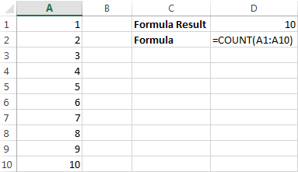](https://www.udemy.com/microsoft-excel-vba-video-tutorial/?couponCode=learn-excel-formulas&tc=blog.excel.1.pic&utm_source=blog&utm_medium=udemyads&utm_content=post6539&utm_campaign=content-marketing-blog&xref=blog)**

This formula only works with numbers though:

**[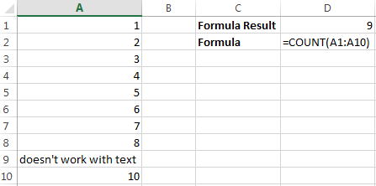](https://www.udemy.com/microsoft-excel-vba-video-tutorial/?couponCode=learn-excel-formulas&tc=blog.excel.1.pic&utm_source=blog&utm_medium=udemyads&utm_content=post6539&utm_campaign=content-marketing-blog&xref=blog)**

It only counts the cells where there are numbers.

* ***COUNTA***

Formula: =COUNTA (A1:A10). Counts the number of non-empty cells in a range. It will count cells that have numbers and/or any other characters in them. The COUNTA Formula works with all data types.

**[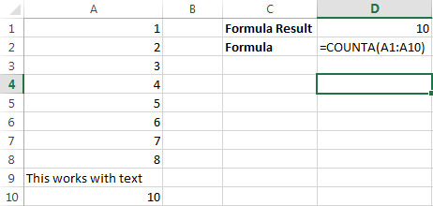](https://www.udemy.com/microsoft-excel-vba-video-tutorial/?couponCode=learn-excel-formulas&tc=blog.excel.1.pic&utm_source=blog&utm_medium=udemyads&utm_content=post6539&utm_campaign=content-marketing-blog&xref=blog)**

It counts the number of non-empty cells no matter the data type.

* ***LEN***

Formula: =LEN(A1), The LEN formula counts the number of characters in a cell. Be careful though! This includes spaces.

**[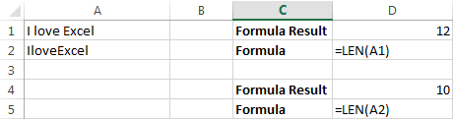](https://www.udemy.com/microsoft-excel-vba-video-tutorial/?couponCode=learn-excel-formulas&tc=blog.excel.1.pic&utm_source=blog&utm_medium=udemyads&utm_content=post6539&utm_campaign=content-marketing-blog&xref=blog)**

Notice the difference in the formula results: 10 characters without spaces in between the words, 12 with spaces between the words.

* ***TRIM***

Formula: =TRIM (A1). Gets rid of any space in a cell, except for single spaces between words. I’ve found this formula to be extremely useful because I’ve often run into situations where you pull data from a database and for some reason extra spaces are put in behind or in front

of legitimate data. This can wreak havoc if you are trying to compare using IF statements or VLOOKUP’s.

**[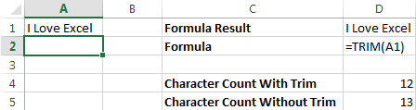](https://www.udemy.com/microsoft-excel-vba-video-tutorial/?couponCode=learn-excel-formulas&tc=blog.excel.1.pic&utm_source=blog&utm_medium=udemyads&utm_content=post6539&utm_campaign=content-marketing-blog&xref=blog)**

I added in an extra space behind “I Love Excel”. The TRIM formula removes that extra space. Check out the character count difference with and without the TRIM formula.

* ***RIGHT, LEFT, MID***

Formulas: = RIGHT (text, number of characters), =LEFT (text, number of characters), =MID (text, start number, number of characters). (Note: In these formulas, wherever it says “text” you can use a cell reference as well)

These formulas return the specified number of characters from a text string. RIGHT gives you the number of characters from the right of the text string, LEFT gives you the number of characters from the left, and MID gives you the specified number of characters from the middle of the word. You tell the MID formula where to start with the start\_number and then it grabs the specified number of characters to the right of the start\_number.

**[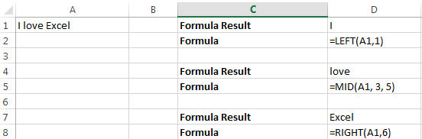](https://www.udemy.com/microsoft-excel-vba-video-tutorial/?couponCode=learn-excel-formulas&tc=blog.excel.1.pic&utm_source=blog&utm_medium=udemyads&utm_content=post6539&utm_campaign=content-marketing-blog&xref=blog)**

I used the LEFT formula to get the first word. I had it look in cell A1 and grab only the 1st character from the left. This gave us the word “I” from “I love Excel” I used the MID formula to get the middle word. I had it look in cell A1, start at character 3, and grab 5 characters after that. This gives us just the word “love” from “I love Excel” I used the RIGHT formula to get the last word. I had it look at cell A1 and grab the first 6 characters from the right. This gives us “Excel” from “I love Excel”

* ***VLOOKUP***

Formula: =VLOOKUP (lookup\_value, table\_array, col\_index\_num, range\_lookup) By far my most used formula. The official description of what it does: “Looks for a value in the leftmost column of a table, and then returns a value in the same row from a column you specify…”. Basically, you define a value (the lookup\_value) for the formula to look for. It looks for this value in the leftmost column of a table (the table\_array).

Note: If possible use a number for the lookup\_value. This makes it a lot easier to make sure the data you are getting back is a correct match.

If it finds a match of the “lookup\_value” in the left column of the “table\_array” it will return the value in the column you specify using the “index\_num”. The “index\_num” is relative to the left most column. So, if you have the table\_index look in column A and you want what is returned to be what’s in column by the “index\_num” would be 2 because the leftmost column, column A in this case, is the 1st column in the table array and column B is the 2nd column (hence the 2 for the index number). If you want what is in column C to be returned you’d put 3 for the index\_num. The “range\_lookup” is a TRUE or FALSE value. If you put TRUE it will give you the closest match. If you put FALSE, it will only give you an exact match. I only use FALSE when using the VLOOKUP formula.

*Example:*

You have 2 lists: 1 with a sales person’s ID and the sales revenue for the quarter. Another with the sales person’s ID and the sales person’s name. You want to match up the sales person’s name to the sales person’s revenue numbers for the quarter. They are all jumbled around

so, to manually match this, even for a small number of salesmen would leave room for a high margin of error and take a lot of time.

The first list goes from A1 to B13. The 2nd list goes from D1 to E25. In cell C1 I would put the formula =VLOOKUP (B18, $A$1: $B$13, 2, FALSE) B18 = the lookup\_value (the sales person’s ID. This is a number that appears on both lists.) $A$1: $B$13 = the “table\_array”. This is the area I want the formula to search the leftmost column (column E in this case) for the “lookup\_value”. I went to F because if it finds match in column E, I want it to return what’s in column F. (The money signs are there so that the table\_array will stay the same no matter where the formula is moved or copied to. This is called an absolute reference.) 2 = the index\_num. This tells the formula the number of columns away from the left most column to return in case of match. So, if you find a match between the lookup\_value and the leftmost column of the table array, return what’s in the same row in the 2nd column of the table (the 1st column is always the leftmost column. It starts at 1, not 0). FALSE= tells the formula I want it to only return the value if it’s an exact match. I would then copy and paste that formula along all the cells in column C next to the first list. This would give me a perfectly aligned list with the sales person’s ID, sales person’s revenue for the quarter, and the sales person’s name.

**[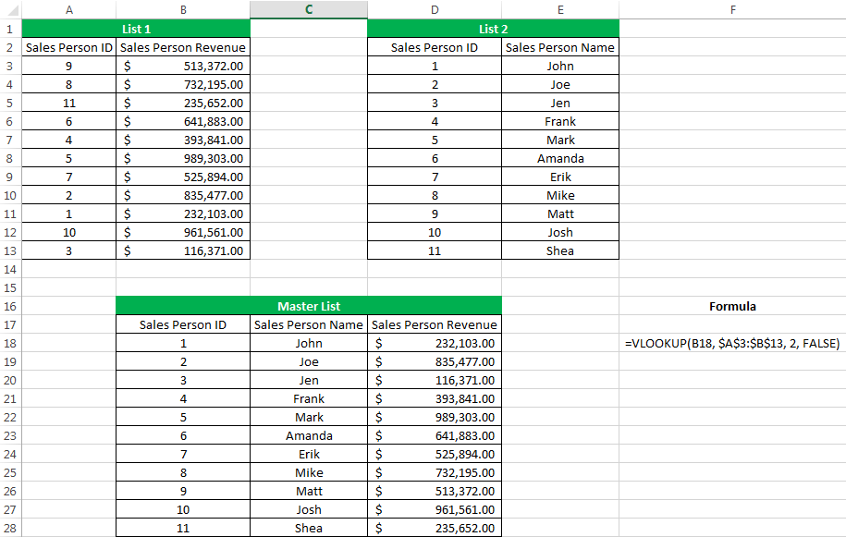](https://www.udemy.com/microsoft-excel-vba-video-tutorial/?couponCode=learn-excel-formulas&tc=blog.excel.1.pic&utm_source=blog&utm_medium=udemyads&utm_content=post6539&utm_campaign=content-marketing-blog&xref=blog)**

To get a nice neat list of Sales Person ID, Sales Person Name, and Sales Person Revenue all next to each other I used the VLOOKUP formula to compare 1 list to another.

* ***IF Statements***

Formula: =IF (logical\_statement, return this if logical statement is true, return this if logical statement is false) When you’re doing an analysis of a lot of data in Excel there are a lot of scenarios you could be trying to discover and the data must react differently based on a different situation. Continuing with the sales example: Let’s say a salesperson has a quota to meet. You used VLOOKUP to put the revenue next to the name. Now you can use an IF statement that says: “IF the salesperson met their quota, say “Met quota”, if not say “Did not meet quota” (Tip: saying it in a statement like this can make it a lot easier to create the formula, especially when you get to more complicated things like Nested IF Statements in Excel).

*It would look like this:*

In the example with the VLOOKUP we had the revenue in column B and the person’s name in column C (brought in with the VLOOKUP). We could put their quota in column D and then we’d put the following formula in cell E1: =IF(C3>D3, “Met Quota”, “Did Not Meet Quota”) This IF statement will tell us if the first salesperson met their quota or not. We would then copy and paste this formula along all the entries in the list. It would change for each sales person.

**[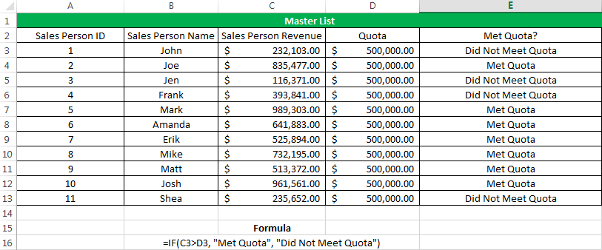](https://www.udemy.com/microsoft-excel-vba-video-tutorial/?couponCode=learn-excel-formulas&tc=blog.excel.1.pic&utm_source=blog&utm_medium=udemyads&utm_content=post6539&utm_campaign=content-marketing-blog&xref=blog)**

Having the result right there from the IF statement is a lot easier than manually figuring this out.

* ***SUMIF, COUNTIF, AVERAGEIF***

Formulas: =SUMIF (range, criteria, sum\_range), =COUNTIF (range, criteria), =AVERAGEIF (range, criteria, average\_range). These formulas all do their respective functions (SUM, COUNT, AVERAGE) IF the criteria are met. There are also the formulas: SUMIFS, COUNTIFS, AVERAGEIFS where they will do their respective functions based on multiple criteria you give the formula.

**[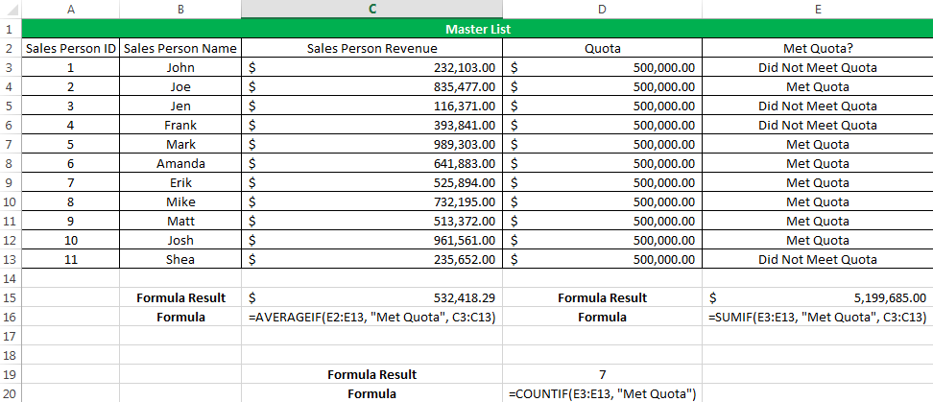](https://www.udemy.com/microsoft-excel-vba-video-tutorial/?couponCode=learn-excel-formulas&tc=blog.excel.1.pic&utm_source=blog&utm_medium=udemyads&utm_content=post6539&utm_campaign=content-marketing-blog&xref=blog)**

I use these formulas in our example to see the average revenue (AVERAGEIF) if a person met their quota, Total revenue (SUMIF) for the just the sales people who met their quota, and the count of sales people who met their quota (COUNTIF)

* ***CONCATENATE***

A fancy word for combining data in 2 (or more) different cells into one cell. This can be done with the Concatenate excel formula or it can be done by simply putting the &symbol in between the two cells. If I have “Steve” in cell A1 and “Quatrani” in cell B1 I could put this formula: =A1&” “&B1 and it would give me “Steve Quatrani”. (The ““puts a space in between what you are combining with the &). I can use =concatenate (A1, ““, B1) and it will give me the same thing: “Steve Quatrani”

**[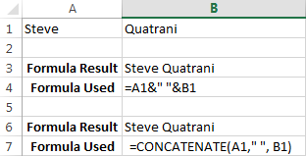](https://www.udemy.com/microsoft-excel-vba-video-tutorial/?couponCode=learn-excel-formulas&tc=blog.excel.1.pic&utm_source=blog&utm_medium=udemyads&utm_content=post6539&utm_campaign=content-marketing-blog&xref=blog)**

Finding the Right Excel Formulas for The Job. There are 316 built in functions in Excel. You’re not going to sit there and memorize what all of them do (or at least I hope not!). Luckily Excel has a built-in wizard that helps you find the correct formula for what you’re looking to do (if there is one). Click the “fx” next to the formula bar in Excel

**[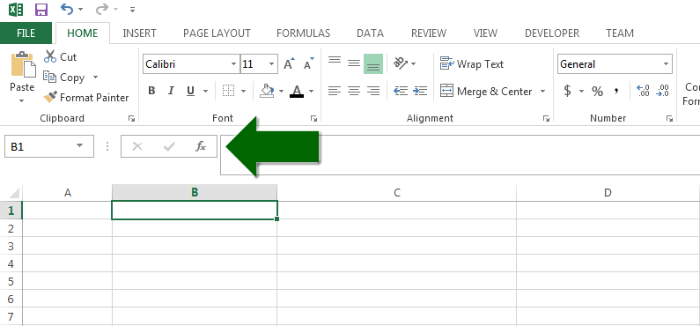](https://www.udemy.com/microsoft-excel-vba-video-tutorial/?couponCode=learn-excel-formulas&tc=blog.excel.1.pic&utm_source=blog&utm_medium=udemyads&utm_content=post6539&utm_campaign=content-marketing-blog&xref=blog)**

This brings up a menu and in there you can type in a description of what you are trying to do and it will bring up the correct excel formula:

**[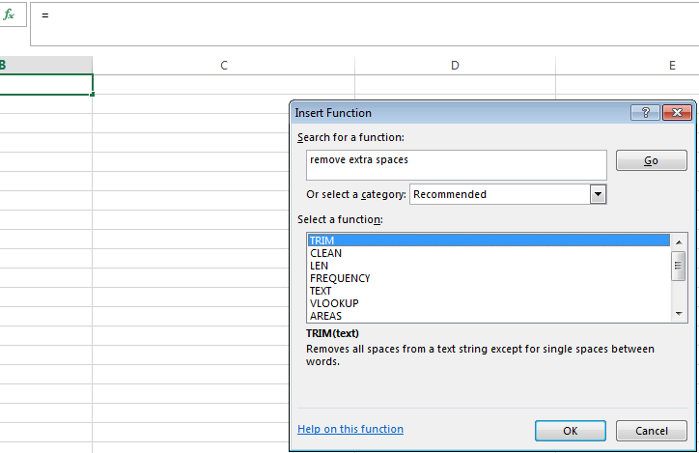](https://www.udemy.com/microsoft-excel-vba-video-tutorial/?couponCode=learn-excel-formulas&tc=blog.excel.1.pic&utm_source=blog&utm_medium=udemyads&utm_content=post6539&utm_campaign=content-marketing-blog&xref=blog)**

I typed in “remove extra spaces” and it returned the TRIM formula that we went over earlier.

**Q10. Discuss Computers Basic use or application.**

A computer is an electronic device that operates under the control of a set of - instructions that is stored in its memory unit. A computer can be more accurately defined as an electronic device that takes¬ data as input, stores and processes it and displays the output per the given instructions. A computer consists of several components. Each component participates in either one of the input, process, or output phases. Characteristics of computer:

***Computers of all sizes have common characteristics: –***

Speed, Reliability, Multitasking, Diligence, Accuracy, Memory capacity

* ***Speed*** It works in very high speeds and can much faster than human.ο It equivalent to one million mathematicians working 24 hours in a day.
* ***Reliability*** Computers are extremely reliable as well. Most errors are caused by humans,ο not computers. Computers can store enormous amounts of data that must beο located and retrieved very quickly.
* ***Multitasking*** Modern computers can perform multiple task at once. i.e. they can perform a set of works simultaneously. Example – at a same time it can play a game & printing your document
* ***Diligence*** Unlike human, computer simply does not get bored or tired.ο Repetitive work does not affect computer.
* ***Accuracy*** Computers rarely make mistakes.ο Most computer errors are caused by human faults
* ***Storage capacity*** It stores huge amount of data / information.

There are countless applications out there, and they fall into many different categories. Some are more full-featured (like Microsoft Word), while others may only do one or two things (like gadgets). Below are just a few types of applications that you might use:

* ***Word Processors:*** A word processor allows you to write a letter, design a flyer, and create many other kinds of documents. The most well-known word processor is Microsoft Word.
* ***Personal Finance:*** Personal finance software, such as Quicken, allows you to keep track of your income and expenses, create a budget, and more. Most personal finance programs can automatically download information from your bank, so you don't have to manually type in all your transactions.
* ***Web Browsers:*** A web browser is the tool that you use to access the World Wide Web. Most computers come with a web browser pre-installed, but you can also download a different one if you prefer. Examples of browsers include Internet Explorer, Firefox, Google Chrome, and Safari.
* ***Games:*** There are many different games that you can play on your computer. They range from card games such as Solitaire to action games like Halo 2.
* ***Media Players:*** If you want to listen to mp3s or watch movies that you've downloaded, you'll need to use a media player. Windows Media Player and iTunes are popular media players.
* ***Gadgets:*** Sometimes called widgets, these are simple applications that you can place on your desktop (or on the Dashboard if you're using a Mac).

***Q17. Write a note on ‘importance of internet in media and its effects on journalism’***

Social media uses web-based and mobile technologies on smartphone and tablet computers to create highly interactive platforms through which individuals, communities and organizations can share, co-create, dis cuss, and modify user-generated content or pre-made content posted online. They introduce substantial and pervasive changes to communication between businesses, organizations, communities and individuals. Social media changes the way individuals and large organizations communicate. These changes are the focus of the emerging field of techno self-studies.Social media differs from paper-based or traditional electronic media such as TV broadcasting in many ways, including quality, reach, frequency, usability, immediacy, and permanence. Social media operates in a dialogic transmission system (many sources to many receivers). This contrasts with traditional media which operates under a monologist transmission model (one source to many receivers), such as a paper newspaper which is delivered to many subscribers. Some of the most popular social media websites are Facebook (and its associated Facebook Messenger), WhatsApp, Tumblr, Instagram, Twitter, BaiduTieba, Pinterest, LinkedIn, Gab, Google+, YouTube, Viber, Snapchat, Weibo and WeChat. These social media websites have more than 100,000,000 registered users.

Observers have noted a range of positive and negative impacts from social media use. Social media can help to improve individuals' sense of connectedness with real and/or online communities and social media can be an effective communication (or marketing) tool for corporations, entrepreneurs, nonprofit organizations, including advocacy groups and political parties and governments. At the same time, concerns have been raised about possible links between heavy social media use and Depression (mood) and even the issues of cyberbullying, online harassment and "trolling". According to Nielsen, Internet users continue to spend more time on social media sites than on any other type of site. At the same time, the total time spent on social media sites in the U.S. across PCs as well as on mobile devices increased by 99 percent to 121

billion minutes in July 2012 compared to 66 billion minutes in July 2011. For content contributors, the benefits of participating in social media have gone beyond simply social sharing to building reputation and bringing in career opportunities and monetary income.

Twitter. Facebook. Digg. Myspace. LinkedIn. The list of social media tools could probably run on for paragraphs, and today’s technology changes so rapidly that many industries, including corporations and news media, can barely keep up. In the traditional world, newspapers, corporations, governments, or other types of leading organizations simply had to give out information, and people would consume it by reading or looking at it. But this seemingly tried-and-true method is transforming.

Simply making information available is not enough for today’s public. Today’s audiences expect to be able to choose what they read, and most believe they should be able to contribute content and opinions, too. This shift, sometimes called the social media revolution, is not the death of journalism as America always knew it; it’s the birth of a democratic movement that emphasizes some of journalism’s key factors: transparency, honesty, and giving a voice to the person who doesn’t have one.

Many traditional and non-traditional media outlets report and comment on how the Internet and social media, especially social networking, have begun to seriously affect news organizations and how they operate. Although newspapers currently face a crisis on how to make the news profitable in the digital age, that isn’t this report’s focus. How papers will make money has been talked to death. So, instead, this report will focus on how social media, especially social networking sites like Twitter, has begun to affect the news organizations and changed — for better or worse — how journalists perform their jobs every day.

The main purpose of this report is to learn how the social media revolution has changed and will continue to change journalism and news organizations. To understand social media and its effects, one must read and analyze information gathered through journal articles, interviews and observations as this report has done. The report is broken into subtopics: a summary of the current state of traditional media; definitions and background information on what social media and social journalism are; social media tools professionals use and why; current event case studies in which social media played a role in reporting the news; ethical issues surrounding the social media shift; and how the future of the news media might look because of social media.

The report will respond to one simple, yet rather complex, question: What impact has social media had on news organizations? A question like this cannot be answered straightforward but must instead be explored. While the report will focus on what has already occurred, it will also look to the future and will consider whether public opinions of the mainstream media have helped spawn and accelerate the birth of the social media revolution. Results will lead the report to offer three areas within journalism that social media has significantly touched: the public’s trust of the news media in relation to social media; the relationship between local news organizations and social media; and how news is and will be covered using social media tools

***Q2. State and explain different types of memory storage in computer devices and state different storage devices and differentiate them in one***

In computing, memory refers to the computer hardware devices used to store information for immediate use in a computer; it is synonymous with the term "primary storage". Computer memory operates at a high speed, for example random-access memory (RAM), as a distinction from storage that provides slow-to-access program and data storage but offers higher capacities. If needed, contents of the computer memory can be transferred to secondary storage, through a memory management technique called "virtual memory". An archaic synonym for memory is store.

The term "memory", meaning "primary storage" or "main memory", is often associated with addressable semiconductor memory, i.e. integrated circuits consisting of silicon-based transistors, used for example as primary storage but also other purposes in computers and other digital electronic devices. There are two main kinds of semiconductor memory, volatile and non-volatile. Examples of non-volatile memory are flash memory (used as secondary memory) and ROM, PROM, EPROM and EEPROM memory (used for storing firmware such as BIOS). Examples of volatile memory are primary storage, which is typically dynamic random-access memory (DRAM), and fast CPU cache memory, which is typically static random-access memory (SRAM) that is fast but energy-consuming, offering lower memory areal density than DRAM.

Most semiconductor memory is organized into memory cells or biostable flip-flops, each storing one bit (0 or 1). Flash memory organization includes both one bit per memory cell and multiple bits per cell (called MLC, Multiple Level Cell). The memory cells are grouped into words of

fixed word length, for example 1, 2, 4, 8, 16, 32, 64 or 128 bit. Each word can be accessed by a binary address of N bit, making it possible to store 2 raised by N words in the memory. This implies that processor registers normally are not considered as memory, since they only store one word and do not include an addressing mechanism. Typical secondary storage devices are hard disk drives and solid-state drives.

***Q19. Explain in detail the basic structure of a PC?***

***(Expand in Detail)*** A computer is an electronic device capable of manipulating number and symbols, first taking input, processing it, storing and giving out output under a control of set instructions which is known as a program. A general-purpose computer requires the following hardware components: memory, storage device (hard disk drive), input device (keyboard, mouse etc.), output device (screen, printer etc.) and central processing unit (CPU). Many other components are involved in addition to the listed components to work together efficiently.

***Q20. What are operating systems? Discuss the different types of operating systems***

***(Expand in Detail)*** An **operating system** or **OS** is a software on the [hard drive](http://www.computerhope.com/jargon/h/harddriv.htm) that enables the computer [hardware](http://www.computerhope.com/jargon/h/hardware.htm) to communicate and operate with the computer [software](http://www.computerhope.com/jargon/s/software.htm). Without a computer operating system, a computer and software programs would be useless

***Operating System types***

* ***GUI* -** Short for Graphical User Interface, a GUI operating system contains graphics and icons and is commonly navigated by using a computer mouse.
* ***Multi-user* -** A multi-user operating system allows for multiple users to use the same computer at the same time and different times.
* ***Multiprocessing* -** An operating system capable of supporting and utilizing more than one computer processor.

***Q21.What is digital designing? Describe the stages in the process of digital designing.***

***(Expand in Detail)*** Aside from industry and market, this was also a move from a predominantly creative culture to one heavily focused on development, both in terms of team and the focus of our products. Process are as follow: -

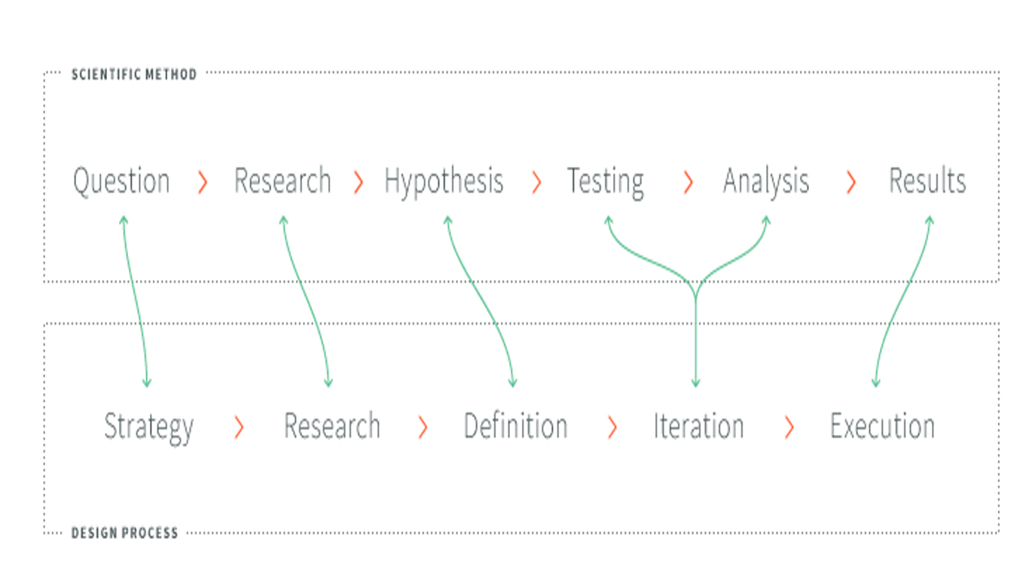

***Q22. What are Raster and Vector images? Explain their pros and cons and their relation to resolution***

***(Expand in Detail)*** A raster image is made of up pixels, each a different color, arranged to display an image. A vector image is made up of paths, each with a mathematical formula (vector) that tells the path how it is shaped and what color it is bordered with or filled by.

The major difference is that raster image pixels do not retain their appearance as size increases - when you blow a photograph up, it becomes blurry for this reason. Vector images do retain appearance regardless of size, since the mathematical formulas dictate how the image is rendered.

***Q24. Explain in detail the types of physical network typologies and mention the advantages and disadvantages of each.***

Network Topology is the schematic description of a network arrangement, connecting various nodes (sender and receiver) through lines of connection.

* ***BUS Topology -*** Bus topology is a network type in which every computer and network device is connected to single cable. When it has exactly two endpoints, then it is called **Linear Bus topology**.

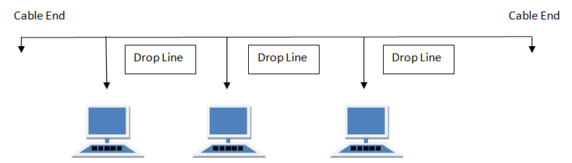

#### **Advantages of Bus Topology**

#### It is cost effective.

#### Cable required is least compared to another network topology.

#### Used in small networks.

#### It is easy to understand.

#### Easy to expand joining two cables together.

#### **Disadvantages of Bus Topology**

#### Cables fails then whole network fails.

#### If network traffic is heavy or nodes are more the performance of the network decreases.

#### Cable has a limited length.

#### It is slower than the ring topology.

* ***RING Topology*** - It is called ring topology because it forms a ring as each computer is connected to another computer, with the last one connected to the first. Exactly two neighbors for each device.

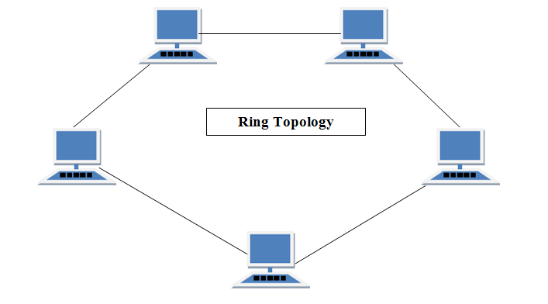

#### **Features of Ring Topology**

#### Several repeaters are used for Ring topology with large number of nodes, because if someone wants to send some data to the last node in the ring topology with 100 nodes, then the data will have to pass through 99 nodes to reach the 100th node. Hence to prevent data loss repeaters are used in the network.

#### The transmission is unidirectional, but it can be made bidirectional by having 2 connections between each Network Node, it is called **Dual Ring Topology**.

#### In Dual Ring Topology, two ring networks are formed, and data flow is in opposite direction in them. Also, if one ring fails, the second ring can act as a backup, to keep the network up.

#### Data is transferred in a sequential manner that is bit by bit. Data transmitted, must pass through each node of the network, till the destination node.

#### **Advantages of Ring Topology**

#### Transmitting network is not affected by high traffic or by adding more nodes, as only the nodes having tokens can transmit data.

#### Cheap to install and expand

#### **Disadvantages of Ring Topology**

* Troubleshooting is difficult in ring topology.
* Adding or deleting the computers disturbs the network activity.
* Failure of one computer disturbs the whole network.
* **STAR Topology** - In this type of topology all the computers are connected to a single hub through a cable. This hub is the central node and all others nodes are connected to the central node.

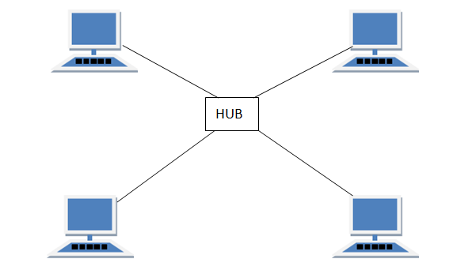

#### **Features of Star Topology**

#### Every node has its own dedicated connection to the hub.

#### Hub acts as a repeater for data flow.

#### Can be used with twisted pair, Optical Fiber or coaxial cable.

#### **Advantages of Star Topology**

#### Fast performance with few nodes and low network traffic.

#### Hub can be upgraded easily.

#### Easy to troubleshoot.

#### Easy to setup and modify.

#### Only that node is affected which has failed, rest of the nodes can work smoothly.

#### **Disadvantages of Star Topology**

#### Cost of installation is high.

* Expensive to use.
* If the hub fails, then the whole network is stopped because all the nodes depend on the hub.
* Performance is based on the hub that is it depends on its capacity
* ***MESH Topology*** - It is a point-to-point connection to other nodes or devices. All the network nodes are connected to each other. Mesh has n(n-2)/2 physical channels to link n devices.

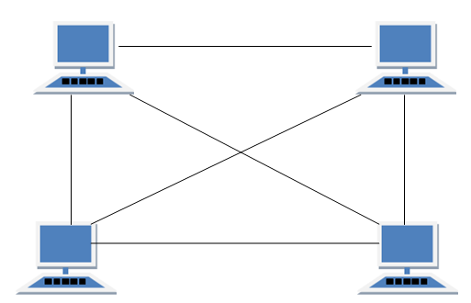

#### **Types of Mesh Topology**

#### **Partial Mesh Topology:** In this topology some of the systems are connected in the same fashion as mesh topology but some devices are only connected to two or three devices.

#### **Full Mesh Topology:** Each and every nodes or devices are connected to each other.

#### **Features of Mesh Topology**

#### Fully connected.

#### Robust.

* Not flexible.

#### **Advantages of Mesh Topology**

#### Each connection can carry its own data load.

#### It is robust.

#### Fault is diagnosed easily.

#### Provides security and privacy.

#### **Disadvantages of Mesh Topology**

#### Installation and configuration is difficult.

#### Cabling cost is more.

#### Bulk wiring is required.

* ***TREE Topology***- It has a root node and all other nodes are connected to it forming a hierarchy. It is also called hierarchical topology. It should at least have three levels to the hierarchy.

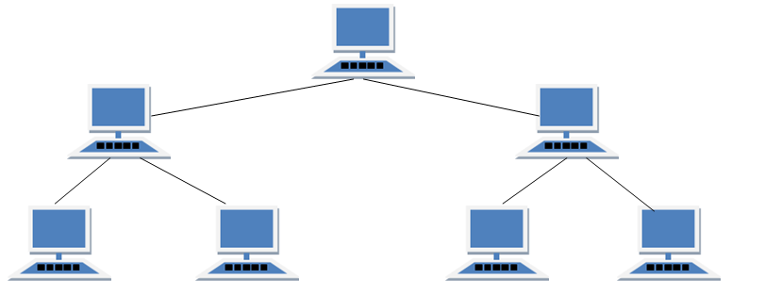

#### **Features of Tree Topology**

#### Ideal if workstations are in groups.

#### Used in Wide Area Network.

#### **Advantages of Tree Topology**

* Extension of bus and star topologies.
* Expansion of nodes is possible and easy.
* Easily managed and maintained.
* Error detection is easily done.

#### **Disadvantages of Tree Topology**

#### Heavily cabled.

#### Costly.

#### If more nodes are added maintenance is difficult.

#### Central hub fails, network fails.

* ***HYBRID Topology*** - It is two different types of topologies which is a mixture of two or more topologies. For example, if in an office in one department ring topology is used and in another star topology is used, connecting these topologies will result in Hybrid Topology (ring topology and star topology).

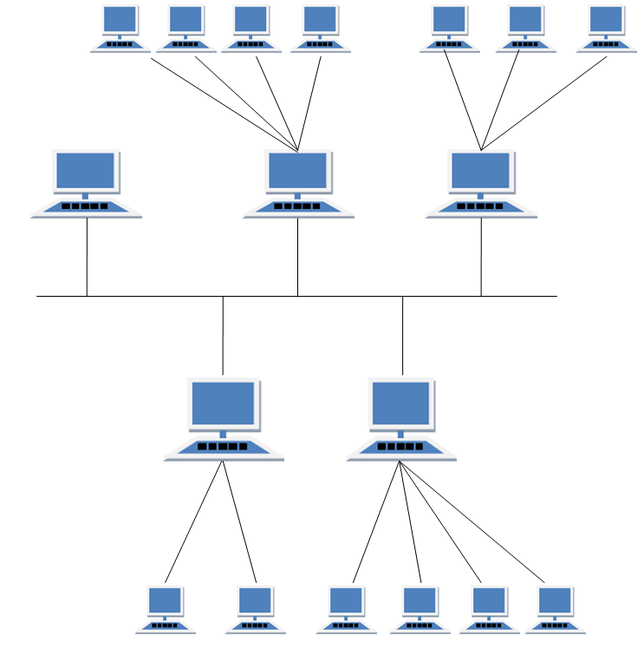

#### **Features of Hybrid Topology**

#### It is a combination of two or topologies

#### Inherits the advantages and disadvantages of the topologies included

#### **Advantages of Hybrid Topology**

#### Reliable as Error detecting and troubleshooting is easy.

#### Effective.

#### Scalable as size can be increased easily.

#### Flexible.

#### **Disadvantages of Hybrid Topology**

#### Complex in design.

#### Costly.

***Q25. Explain memory and its types?***

A memory is just like a human brain. It is used to store data and instructions. Computer memory is the storage space in computer where data is to be processed and instructions required for processing are stored. The memory is divided into large number of small parts called cells. Each location or cell has a unique address which varies from zero to memory size minus one.Memory is primarily of three types

1.Cache Memory

2.Primary Memory/Main Memory

3.Secondary Memory

* Cache Memory - Cache memory is a very high speed semiconductor memory which can speed up CPU. It acts as a buffer between the CPU and main memory. It is used to hold those parts of data and program which are most frequently used by CPU. The parts of data and programs are transferred from disk to cache memory by operating system, from where CPU can access them.
* Primary Memory (Main Memory) - Primary memory holds only those data and instructions on which computer is currently working. It has limited capacity and data is lost when power is switched off. It is generally made up of semiconductor device.

These memories are not as fast as registers. The data and instruction required to be processed reside in main memory. It is divided into two subcategories RAM and ROM.

* Secondary Memory - This type of memory is also known as external memory or non-volatile. It is slower than main memory. These are used for storing data/Information permanently. CPU directly does not access these memories instead they are accessed via input-output routines. Contents of secondary memories are first transferred to main memory, and then CPU can access it. For example: disk, CD-ROM, DVD etc.

***Q26. Define Visual Communication design? Explain the stages involved in a design process***

***(Expand in Detail)*** Visual communication is communication through a visual aid and is described as the conveyance of ideas and information in forms that can be read or looked upon. Visual communication in part or whole relies on vision, and is primarily presented or expressed with two dimensional images, it includes: signs, typography, drawing, graphic design, Illustration, Industrial Design, Advertising, Animation color and electronic resources

***Q27. Explain the types of ecommerce with suitable examples in real world***

***(Expand in Detail) (Refer Other Question in Bank for Answer)*** There are 6 basic types of e-commerce: Business-to-Business (B2B) Business-to-Consumer (B2C), Consumer-to-Consumer (C2C), Consumer-to-Business (C2B), Business-to-Administration (B2A) & Consumer-to-Administration (C2A)

***Q28. Explain different kinds of printers and discuss the printer mechanisms through relevant diagrams.***

***(Refer Other Question in Bank for Answer)* Printers** are Output devices used to prepare permanent Output devices on paper. Printers can be divided into two main categories:

* ***Impact Printers***: In this hammers or pins strike against a ribbon and paper to print the text. This mechanism is known as electro-mechanical mechanism. They are of two types.

**(I) Character**[**Printer**](http://ecomputernotes.com/fundamental/input-output-and-memory/what-is-a-printer-and-what-are-the-different-types-of-printers)

**(II)**[**Line Printer**](http://ecomputernotes.com/fundamental/input-output-and-memory/what-is-line-printertype-of-line-printer)

* ***Character Printer****:* It prints only one character at a time. It has relatively slower speed. E.g. Of them are Dot matrix printers.
* **Dot Matrix Printer**: It prints characters as combination of dots. Dot matrix printers are the most popular among serial printers. These have a matrix of pins on the print head of the [printer](http://ecomputernotes.com/fundamental/input-output-and-memory/what-is-a-printer-and-what-are-the-different-types-of-printers) which form the character. The [computer](http://ecomputernotes.com/fundamental/introduction-to-computer/what-is-computer) [memory](http://ecomputernotes.com/fundamental/input-output-and-memory/what-are-the-different-types-of-ram-explain-in-detail) sends one character at a time to be printed by the printer. There is a carbon between the pins & the paper. The words get printed on the paper when the pin strikes the carbon. There are generally 24 pins.

***Q30. Explain in detail the various internet services available today.***

Internet service providers (ISP - Internet Service Provider) companies or institutions (such as T-Com, Iskon or CARNet in Croatia, AT&T in US and MTNL in India), which satellite or optical connections with several major Internet nodes abroad (mainly in the direction of America and Europe) and the thus ensuring high capacity connection to the rest of the Internet world. However, practice has shown that it can barely follow the needs of the growing number of members of Internet communities. When selecting an ISP of significance is the number of services that it provides to its customers. All services provided by e-mail, but do not provide any service to FTP, newsgroups, renting space on the disc, certain program support etc. CARNet allows for almost all university departments.

***User from their computers at work or at home by joining the Internet can:***

Exchange electronic mail (e-mail) to any Internet user in any location on the planet. Participate in off-line (indirectly, not in real time) discussions via e-mail with people with similar interests through 'mailing lists' and 'News Groups’. Participate live (in real time) in a conversation with another person via the 'Internet video phone' (like Skype), or audio-video conferencing between multiple people using a specially designed computer programs and equipment. Participate in on-line (directly, in real time) written discussion with a larger group of people who use the 'Internet Relay Chat' (IRC) service - chat rooms. To work on a remote computer using the 'Telnet' service or some per function quite the

same. Take files of any type (download) from remote computers and deliver files (upload) them with an FTP (File Transfer Protocol) service. Reading complex documents using 'hypertext'. Clicking on a keyword or image on the screen the user is automatically goes to other facilities within the same or other domains. Read multimedia documents found on WWW (World Wide Web) that contain text, graphics, sound, and video using intelligent browser web presentation, as 'Google Chrome', 'Firefox' or 'Internet Explorer' program support. Learning and practicing for the exam and achieve appropriate certification. Search the Web, documents, various WWW sites or via dedicated international service, as 'Google' and 'Yahoo!', oversubscribed keywords to find the desired documents. Publicly disclose their images or pictures of his grandchildren, and who wants to can publish a picture of mother in law. Advertise your business in a variety of ways, from setting up video clips to the creation of their own website. Paying bills through the 'Internet Banking’. Buy and spend money :-), advertise and offer for sale. Read web editions of newspapers or say 'IT Alphabet’. Play simple games and .... who knows what else.